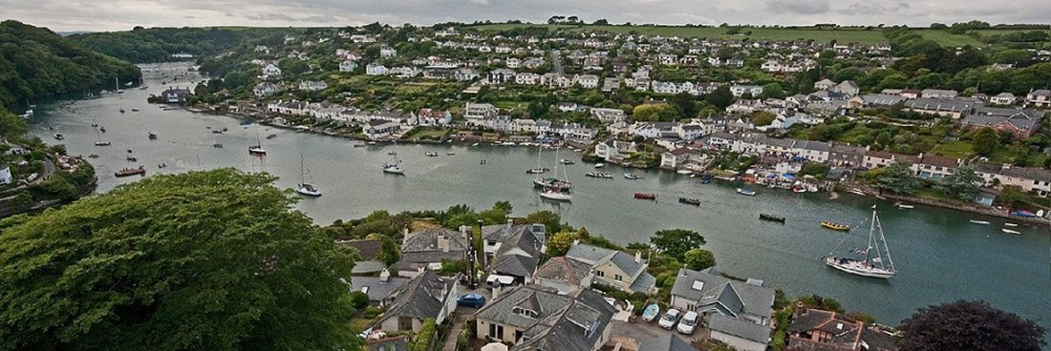
RYDA Newsletter 02/2024
Every language has a few phrases that don't always translate well — and the British English has some absolute corkers. They give us a range of common phrases, such as ‘gallows humour’.
The precise origins of old phrases are notoriously difficult to pin down. (My references for the above come from both contemporary sources and modern histories.) What seems to connect all these expressions is an irreverence and sang froid in the face of death. To have "a good dying" — to go to your death with poise, courage and a flash of wit — was the finest compliment the London crowds could give a convict.
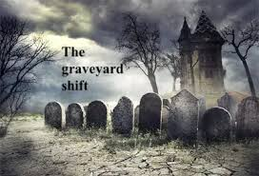
- Saved by the bell or on the graveyard shift; In bygone times there was a lack of places to bury people after they had died – so people would dig up coffins after a number of years in order to reuse the graves. When the coffins were opened, around one in 25 were found to have scratch marks on the inside. They had been burying people alive!
To prevent this from happening again, a string was tied to the deceased's wrist and guided up through the ground, where it was tied to a bell. Someone would have to sit out in the graveyard all night and listen out in case it rang. 'Graveyard shift' also refers to the practice of sitting in a graveyard overnight to guard against grave robbers.
These days, it means a late or overnight work shift.
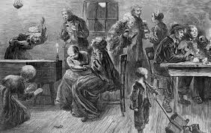
- A Wake; Many people were buried alive in times past because it was not recognized that they might simply be in a coma. This was especially true of people who drank.
Thus, a body was usually left out for a while, and a party thrown around it – just to make sure the corpse didn't 'wake' up!
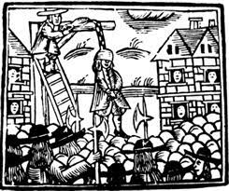
- pulling one’s leg’ supposedly refers to a particularly tortuous experience before the authorities introduced the so-called ‘long drop’ method of hanging in 1872. This more ‘humane’ method killed its victims by dislocating their neck, causing death more quickly. But the old ‘short drop’ method slowly strangled its victims. Friends and family would crowd around the scaffold, ‘pulling the legs’ of their loved one to hasten their demise.
- One for the Road; During the middle ages & Mediaeval period, the condemned were taken from London city gaols to Tyburn Hill for execution.
En route, along what is todays Oxford Street, the cart stopped and they were allowed one final drink at a country inn situated on the road. The “one” they were drinking was for the road to death.
These days, the phrase is used for the final drink before heading home; - it still could also be the last drink you ever have.

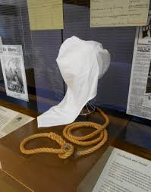
"A leap in the dark."While this term wasn’t invented at Tyburn, it was certainly popularized there. The hangman would roll a hood over the prisoner’s face just before the cart pulled away. It was probably better than facing a hundred thousand cheering spectators. And they were certainly jumping into the unknown, as the expression now suggests.

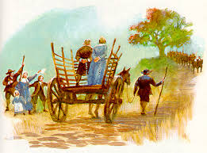
"Left in the lurch." Also somewhat disputed, but this one feels convincing. A "lurch" was another term for the cart or wagon used to convey the prisoners to Tyburn. Sometimes a prisoner would be left in the cart while the constables went off for a drink. So to be "left in the lurch" came to mean being abandoned.

Sustainable South Hams in 2023
Our recent Christmas Celebration gave us the chance to hear about some of your proudest achievements from 2023, and was also a reminder of how much has happened for Sustainable South Hams in the last year!
Follow the link for a round up of where we’re at now, what we’re looking forward to, and the wide range of things we’ve been up to, including working with the District Council, our upcoming Composting Pilot series, Keep It Local, the Rivers Assembly, and lots of great Change Makers events.

Change Makers: Climate Adaptation with the Bioregional Learning Centre
Wed 21st February, 7.30pm - 9.30pm
Online (Zoom)
The new Devon, Cornwall and Isles of Scilly Adaptation Strategy can act as a good basis for local action within smaller regions, presenting an opportunity to be proactive in our response to a changing climate. This online event, co-hosted with the Bioregional Learning Centre (BLC), will open up the conversation around how communities can become solutions-focused.
The event is free, but please book at the link or email info@sussh.org to receive the meeting login details.
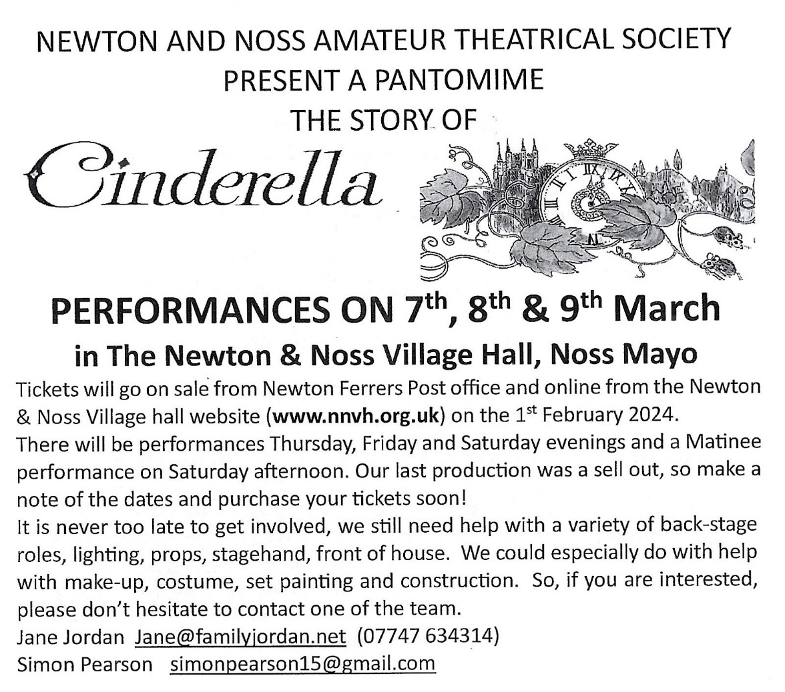

AUDITIONS FOR SHAKESPEARE PRODUCTIONS!

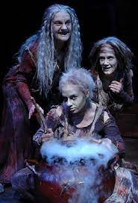
Following the success of last year's outdoor production of A Midsummer Night’s Dream the Wild Will Company plan to repeat the production of the Dream this September alongside a brand new production of Macbeth.

The hope is to create an Annual Shakespeare Festival held in Mothecombe Gardens, near Holbeton.

The plays will be staged outdoors come rain or shine in Mothecombe Gardens and grounds, mid-September 2024. Rehearsals will also take place in this location through spring and summer.

If you love acting and are interested in auditioning for a part please send the following information by email to clarefardon@gmail.com as soon as possible as auditions will start at the end of January and run through February.
· Name
· Age
· A brief summary of any relevant experience
· A photo

*********************
The share raises by Yealm and the other community benefit societies were the final steps in completing the refinance of the CORE portfolio and enabling transfer of the solar farms into community ownership. We are pleased to let you know that all the necessary agreements completed on 15th December, after the signing of a mountain of paperwork. Creacombe, Marlands and Newton Downs solar farms are now in our ownership!
The farms are now financed by a long-term, low-cost loan from abrdn, a shorter-term loan from Power to Change and Big Society Capital and £493,000 of Member capital.
As an integral part of the refinancing process, we are now part of the Community Energy Together family https://www.communityenergytogether.co.uk/about . Our five member societies have a total of 36MW of generation capacity and we are committed to working together and supporting each other for the benefit of all.
For the immediate future, our priority is to familiarise ourselves with the operational management of farm ownership, working closely with Bright Renewables, our asset management partner. We will provide you with updates via newsletters and social media postings. We also anticipate holding our first Members’ annual general meeting in June, or July.
We are now looking to add 2, or 3 additional directors, and should any of you have an interest, we would be delighted to hear from you, so we can have a non-commitment exploratory discussion. We can be contacted at info@yealmenergy.co.uk , or via the following ‘phone numbers (Peter Brown, Chairman 07802-847-495, or Dominic Crawley, Director 07771-796-058).

A few more photos of our villages in the past
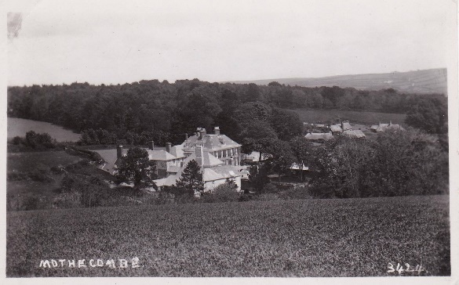
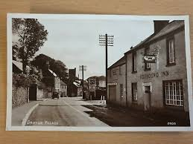

Brixton Mothecombe

Cellars Beach Brixton Stores
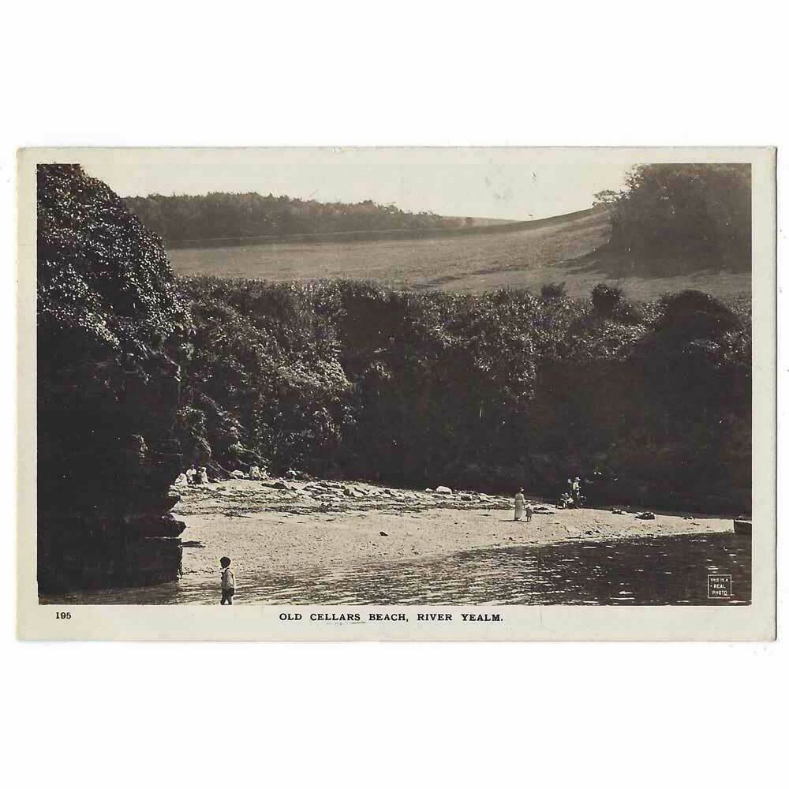
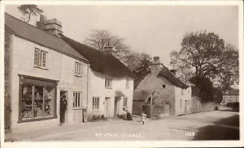

*********************
Some people are experiencing problems with receiving phone calls (as far as we can tell, this applies mainly to Gigaclear), however, with the anticipated switch over to digital other networks could be impacted. The solution to this seems to be to use the dialling code when phoning a local number.

Do you use the WI Community Hall?
Could you find time to join the committee (approx. 4 meetings a year), and help the friendly team obtain quotes for maintaining the hall.
It isn’t arduous work as professionals are hired to do the work where applicable.
Can you take minutes?
Can you change a light bulb?
Would you know if a contractor is genuine?
Do you have mates or contacts in the building trade who might like local work?
Everyone is welcome to assist us we have potentially at least 4 spaces to fill in order to spread the workload.

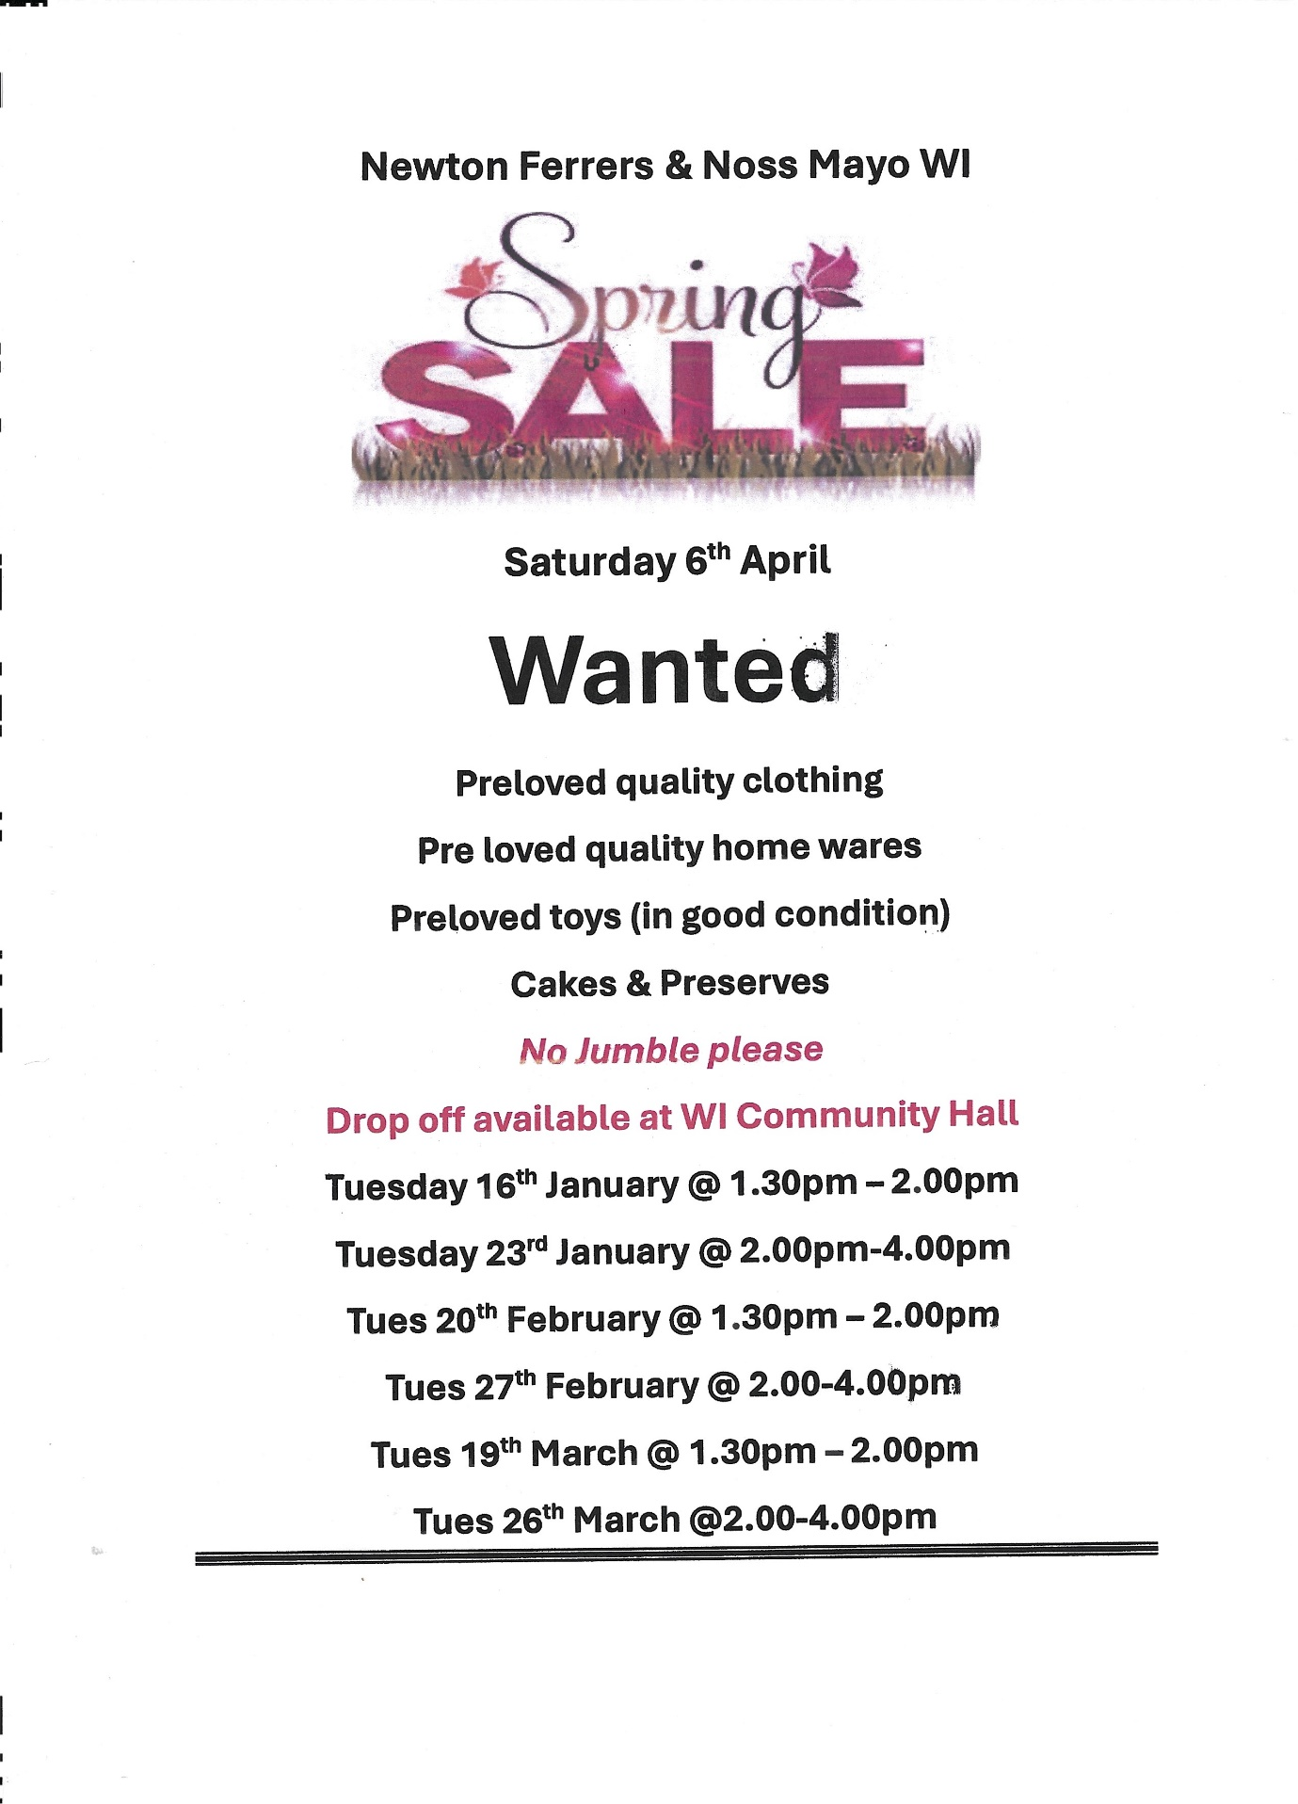

Planning
River Yealm AkzoNobel remediation

As the next part of the process for the remediation package at the Old Paint Laboratory, AkzoNobel have applied for a licence to MMO and this is now available on the MMO portal at the following link:

https://marinelicensing.marinemanagement.org.uk/mmofox5/fox/live/MMO_PUBLIC_REGISTER/
The case number is MMO/2023/00454
The search function on the portal does not seem to work but you can scroll down to 00454.
We have a coordinated group of local organisation headed by the NNPC which includes the RYHA. This group has been given a consultative status by the MMO and whilst it is not fully understand what this is, we believe that submissions made through this route will be given greater weight as one voice.

We will submit a document to the consultation and look for comments for inclusion by the 9th February 2024 so that we can do this in a coordinated manner

The ANTICIPATED timeline is.

Public meeting March/April 2024
Remediation starts Q4/2024 , Q1/2025

If you have any submission on the proposals please forward to Alan Lomax al@lomcroft.plus.com by the 9th February!

3792/23/HHO 93, Court Road, Newton Ferrers. application for roof extensions & alterations to property

4030/23/CLP Williams Quay, Lower Court Road, Newton Ferrers. Certificate of lawfulness for proposed construction of new double garage accessed from court wood.

4129/23/HHO Cleve Moor, Noss Mayo application for internal modifications to annex & replacement of porch with conservatory (resubmission of 3081/23/HHO)

3885/23/FUL Stoke Beach Caravan Park, Noss Mayo, Replacement of corrugated roof with slate and re-clad of walls of ablution block (part retrospective)
3965/23/HHO Whitemoor Cross Holbeton application for installation of heat pump
3684/23/HHO Ford Farmhouse, Ford, Holbeton Listed building consent
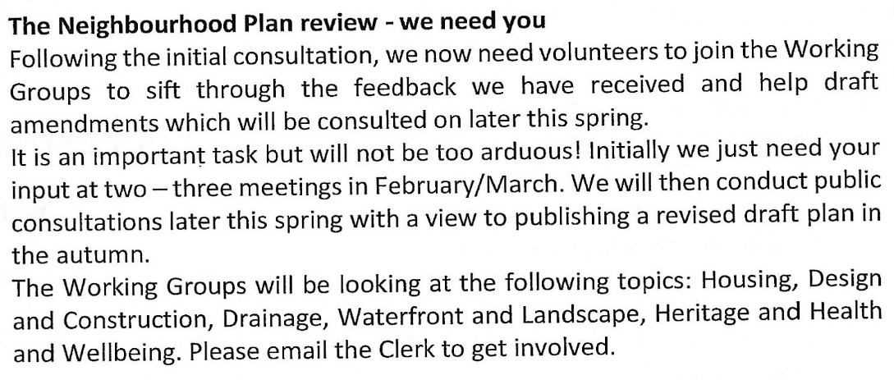
Whats On

Sea Watch Saturday! 3 February 8:30am - 10:30am Wembury Point, Plymouth
D﻿evon Wildlife Trust's Marine Engagement team are kicking off monthly sea watches at Wembury Point! Join us on the first Saturday of each month, to learn all about Devon's marine life.

As part of the Saving Devon's Treescapes project we are giving away free trees for people to plant in their gardens.
Uplyme (Saturday 3 February) From 10:00 till the trees are gone. Uplyme Village Hall (rear car park)
Dunsford (Saturday 3 February) From 10:00 till the trees are gone. Dunsford Village Hall
Newton Abbot (Saturday 3 February) From 10:00 till the trees are gone The Courtenay Centre, Kingsteignton Road

RIVER YEALM HARBOUR AUTHORITY
ELECTION OF MOORING HOLDER REPRESENTATIVES (2024)
An election is due to be held to elect 3 Mooring Holder Representatives to the Authority for the ensuing three years commencing 1st March 2024. The Representatives due to retire are eligible for re-election. Each holder of a current mooring licence may nominate up to 3 persons. Nominations, stating both the proposer’s and the candidate’s names, and confirming that the nominee(s) is/are willing to stand, should be sent to the Clerk to the Authority, Harbour Office, Yealm Road, Newton Ferrers, PL8 1BN not later that 12th January 2024.
A meeting of authorised holders of mooring licences will be held on Tuesday 6th February 2024 in the WI Hall, Newton Ferrers when a ballot of the persons attending the meeting will take place from 18.00 to 20.00, and the names of those elected announced.

First Tuesday Lunch Club 6th February @12.00. £6 for 2 course meal plus tea or coffee. Newton Ferrers Community Hall. Allergies can be catered for. Please contact either Jeanne (872442) or Jane (872627) New members welcome

8th February PC meeting Newton and Noss Village hall 6pm -9pm

9th February Holbeton Film Club are showing Barbie @7.00pm Set in the colorful Barbie Land, stereotypical Barbie lives a perfect life every single day. One day, she shows signs of being...a human. She decides to go to the Real World to find the cure in order to make herself perfect again.

Newton & Noss Village Hall Presents
a Fundraising Evening with…

‘The Blue Jewel Ceilidh Band’
A Lively Evening of Music & Dancing

Friday 9th February 7.30pm – 10.30pm
Village Hall, Noss Mayo

Tickets £20 each to include a Cornish Pasty
Bar Available at Reasonable Prices

Tickets available from
N&N Village Hall website at https://www.nnvh.org.uk
Or Louise Holman 01752 873050
(All profits go to the ongoing Village Hall Repair Fund)

Shoresearch Volunteer Survey Tuesday 13 February 2024 1:30pm - 3:30pm
Wembury Marine Centre, Wembury, Devon
Join Devon Wildlife Trust’s Wembury Marine Centre for a Shoresearch Survey at Wembury Beach!

14th February. There is no Gentle Exercise class as it is half term.

Change Makers: Climate Adaptation with the Bioregional Learning Centre
Wed 21st February, 7.30pm - 9.30pm Online (Zoom)
22nd February Thursday Lunch Club @12.15 £6 Newton and Noss Village hall. It will be low water at 11am. Please contact mrandmrsbarnett@gmail.com Allergies can be catered for. New members welcome
23rd February Yealm Parchment Group meet in Newton Ferrers Community Hall. @ 2pm, with individual tables so you can maintain social distancing. Come along and experience this engrossing 15th Century art form. This month we will be working with a dry on wet painting technique.
We are a small friendly group who work at their own pace.
Tools can be provided if necessary. Tel Lesley 07838375449 £8 Parchment, pattern, backing papers, written instructions and tuition included.

On Friday 23rd February at 1030 in the WIC Hall the U3A have been able to arrange a talk by the Yealm Medical Centre on the Anima online appointment booking system. The talk will be given by the Practice Manager and 2 IT staff. You are welcome to attend this talk, which is free of charge.

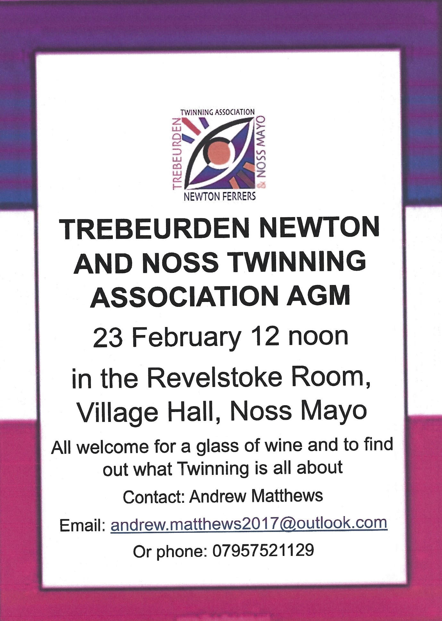

Regular Weekly Events around the Parishes of the River Yealm
Please check with venue/organiser
Events may be cancelled around school holidays etc

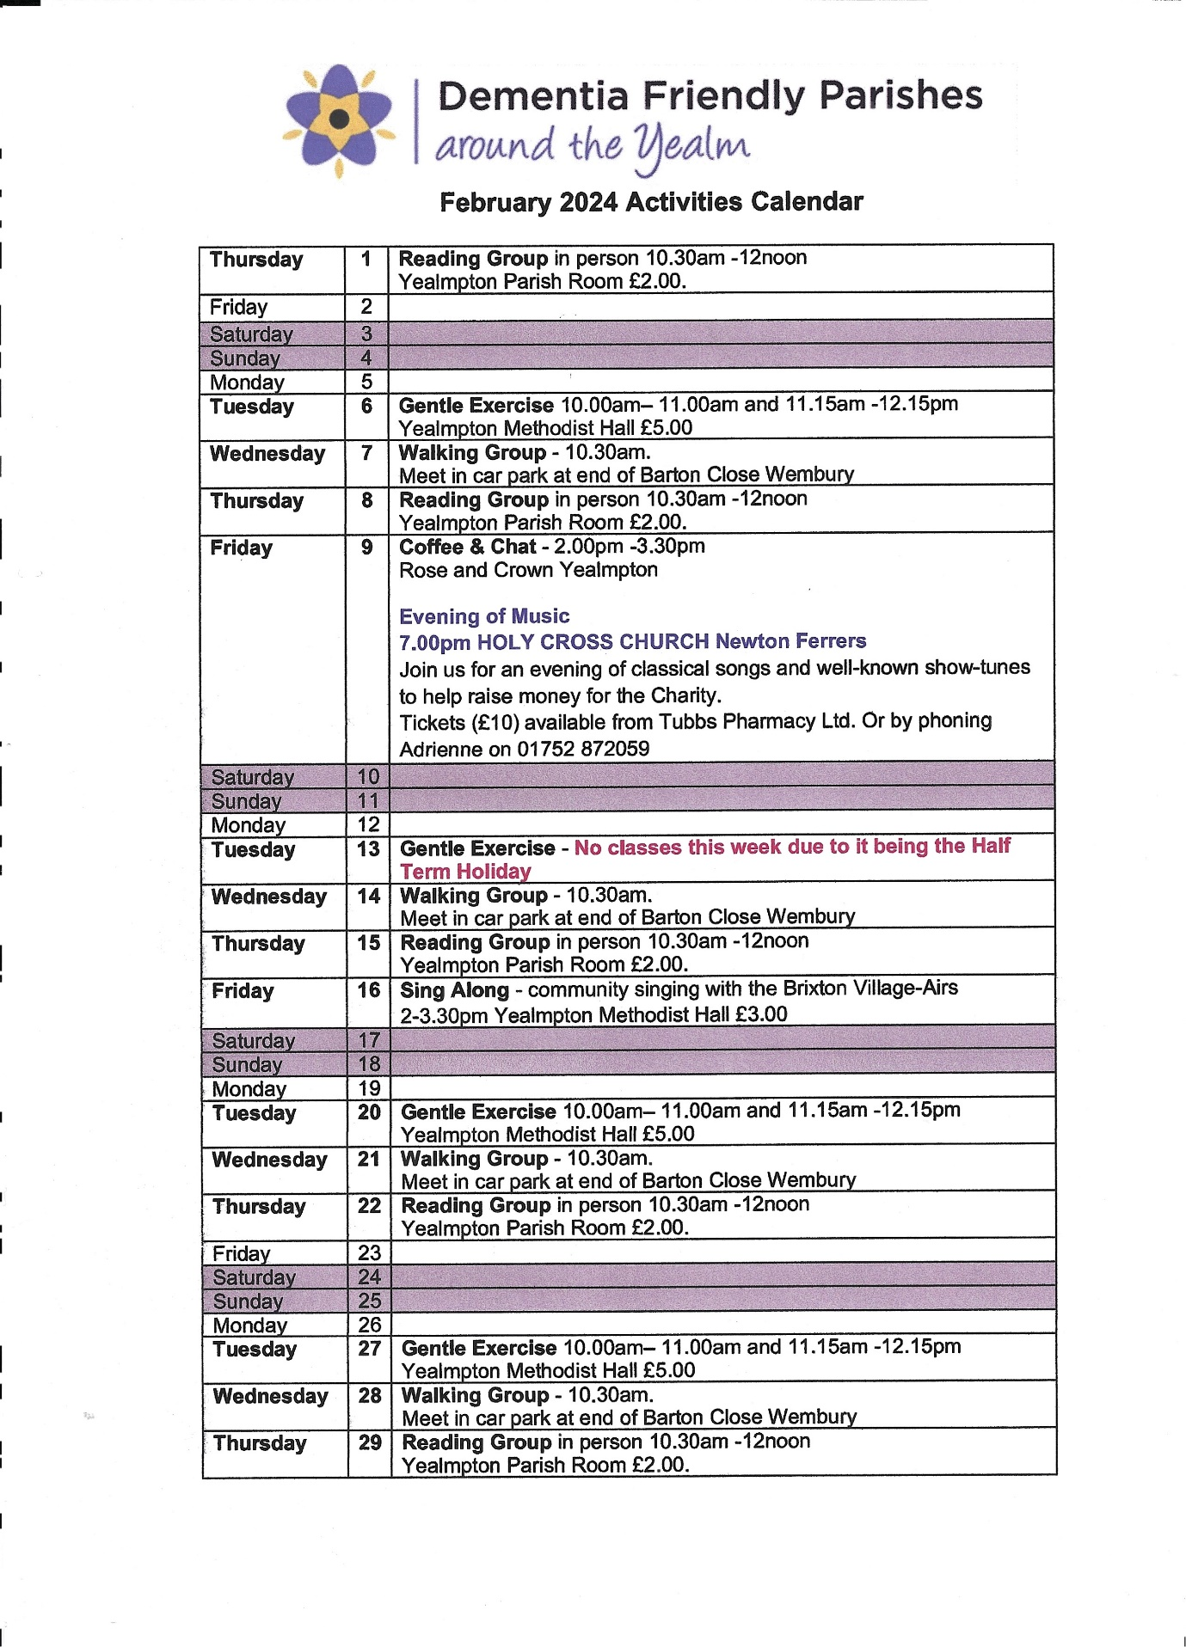

Day | Time | Details | Venue/ contact number
Mon | 12.45-15.45 | Upholstery group | WI Hall Newton Ferrers
 | 9.00 -12.00 | Mens Shed | Mens Shed Yealmpton
 | 16.00-18.15 | Ballet 4-8.15pm | WI Hall Newton Ferrers
 | 18.00-19.30 | Tai Chi | Newton & Noss Village Hall
 | 19.00-21.00 | Badminton | Yealmpton Gt Hall
Tues | 10.00-11.00 | Gentle Exercise | Yealmpton Methodist Church
 | 10.00-11.00 | Yoga | Yealmpton 0780971765
 | 10.00-12.00 | Bowling | Yealmpton Bowling Club
 | 10.30-11.30 | U3A Table Tennis | Newton & Noss Village Hall
 | 18.15-19.15 | Yoga | Yealmpton 07985532992
 | 19.30-20.30 | Vinyasa Yoga | Yealmpton 07985532992
 | 19.30-21.30 | Bridge | Yealmpton 880613
Wed | 9 am-12.00 | Mens Shed | Mens Shed Yealmpton
 | 10.00-11.00 | Gentle exercise class | WI Hall Newton Ferrers
 | 10.30 | Gentle Walking group | Car Park Barton Close Wembury
 | 12.15 | Pilates | Newton & Noss Village Hall
 | 14.00 | WI Choir | WI Hall Newton Ferrers
 | 17.45-19.30 | Karate | Yealmpton 0787360391
 | 18.00 | Bridge | WI Hall Newton Ferrers
 | 18.00 | Gig Exercise Class | Newton & Noss Village Hall
Thurs | 9.30 | Sarah’s fitness (alt weeks) | WI Hall Newton Ferrers
 | 10.30-11.30 | Reading Group | Yealmpton Parish Rooms
 | 12.45 | Yin to Yang Yoga | WI Hall Newton Ferrers
 | 19.00-21.00 | U3A Table Tennis | Newton & Noss Village Hall
 | 19.00 | Pilates | Rose & Crown function room
Fri | 10.15-12.00 | Digital Drop-In | WI Hall Newton Ferrers
 | 10.30 | Yealmpton & Brixton coffee | Yealmpton Community room
 | 10.30 | Songs & Stories | Yealmpton Methodist Church
 |  | Poetry Group | Yealmpton 07749206347
Sat | 10.30-12.30 | Accessible Bowls | WI Hall Newton Ferrers
 | 9 am-12.00 | Mens Shed | Mens Shed Yealmpton

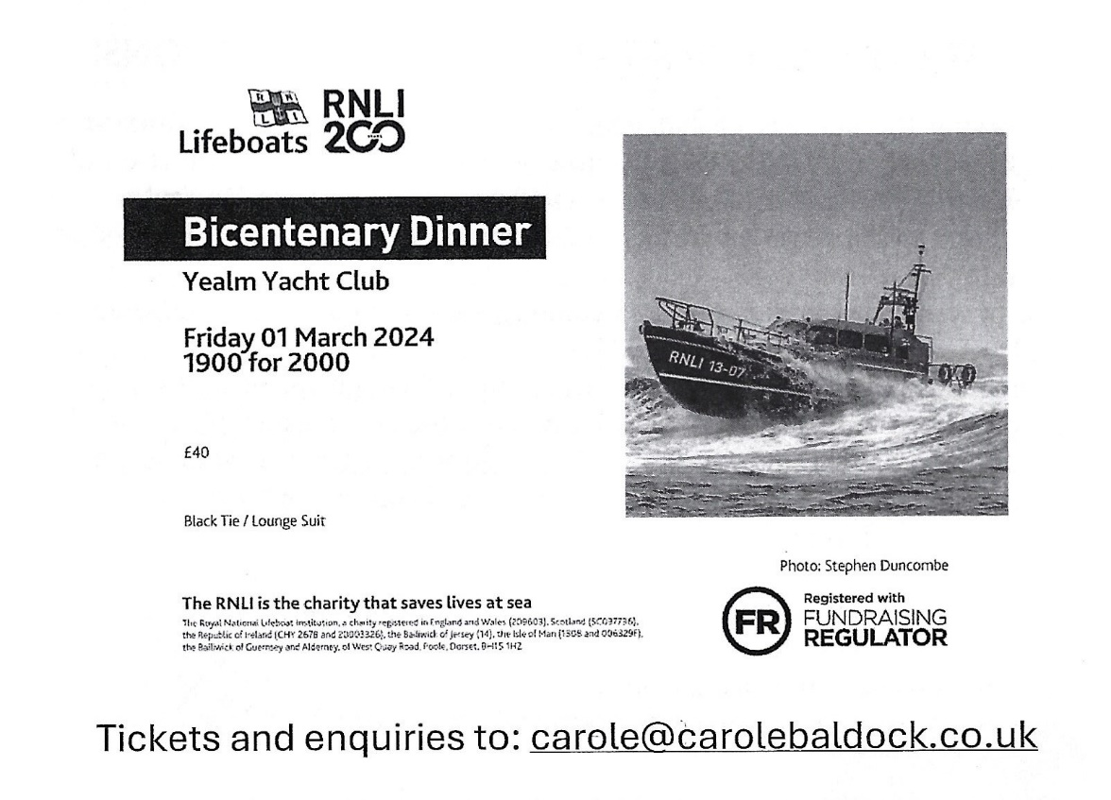
Save the Date

Sea Watch Saturday 2 March 2024 8:30am - 10:30am
Wembury Point National Trust Car Park. Come and join us for a monthly sea watch at Wembury Point
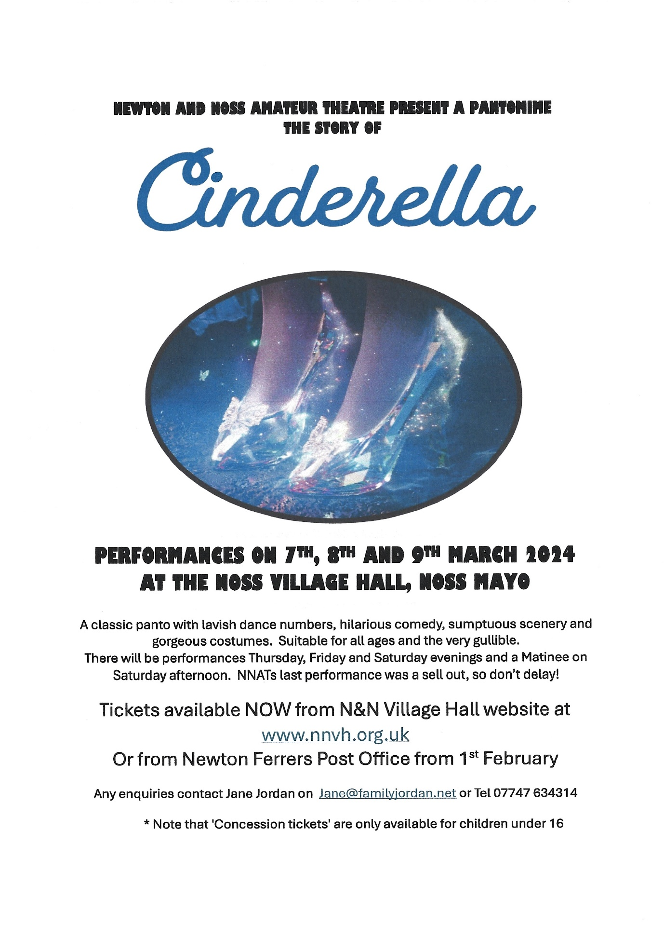

Shoresearch Volunteer Survey Tuesday 12 March 2024 12:00pm - 2:00pm
Wembury Marine Centre, Wembury, Devon
Join Devon Wildlife Trust’s Wembury Marine Centre for a Shoresearch Survey at Wembury Beach

PUMA
(Plymouth Ukraine Medical Aid)
FUNDRAISING SUPPER AND AUCTION
15th March 2024 - 1900 - YYC
Tickets: £25 from Dick Page 01752 872344; dickpage1@gmail.com
or Lesley Challacombe 01752 872233; lesley@coldvalley.co.uk

The Newton Ferrers & Noss Mayo
WI Community Hall Trust
Registered Charity 1054164
Chairman: Val Venning Secretary: Jeanne Venning
Notice
The Annual General Meeting of the above Trust will be held
On
Tuesday 21st March 2024
At 6.00pm
Please support us by coming to the meeting.
Even better come and stand for election to join the committee so that you can have your say on how the hall is operated.
Reply to Jeanne Venning 872442

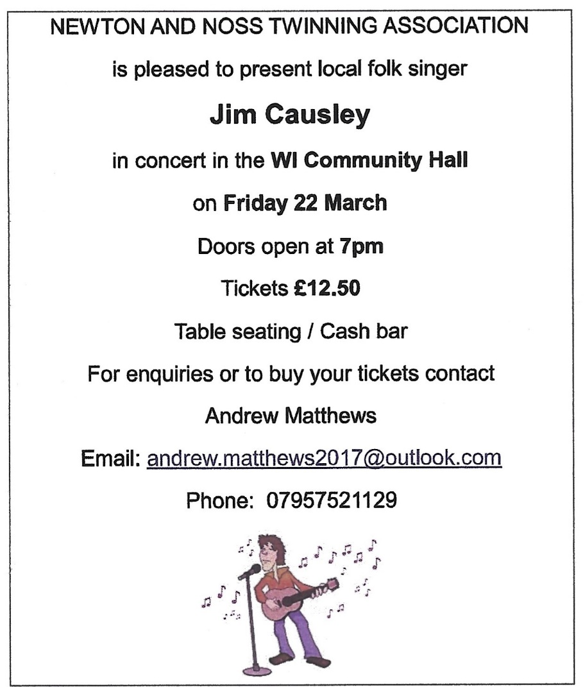

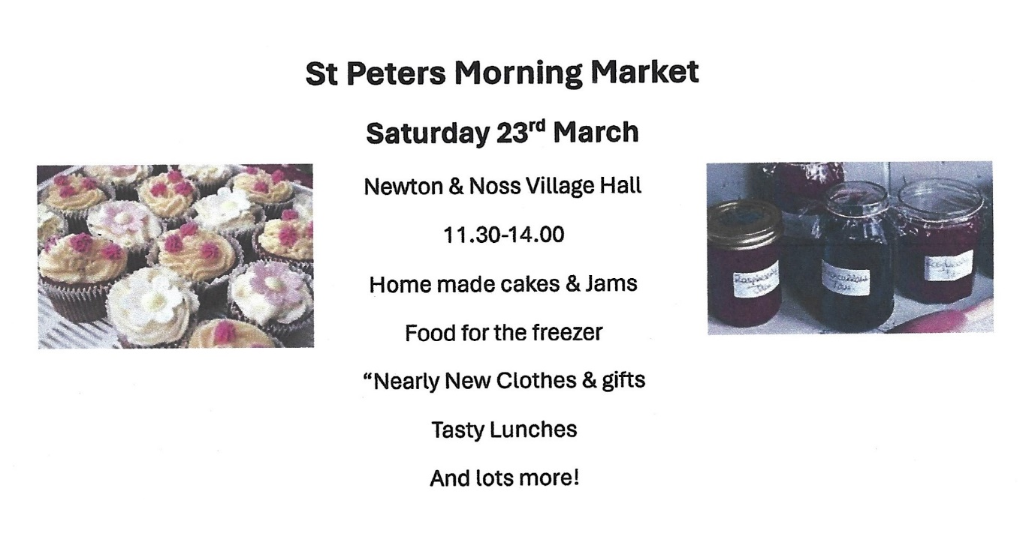

Rockpool Safari Saturday 30 March 2024 1:30pm - 3:00pm Wembury Marine Centre, Wembury, Devon
Join our Devon Wildlife Trust staff and volunteers for a guided tour of some of the best rockpools in the UK

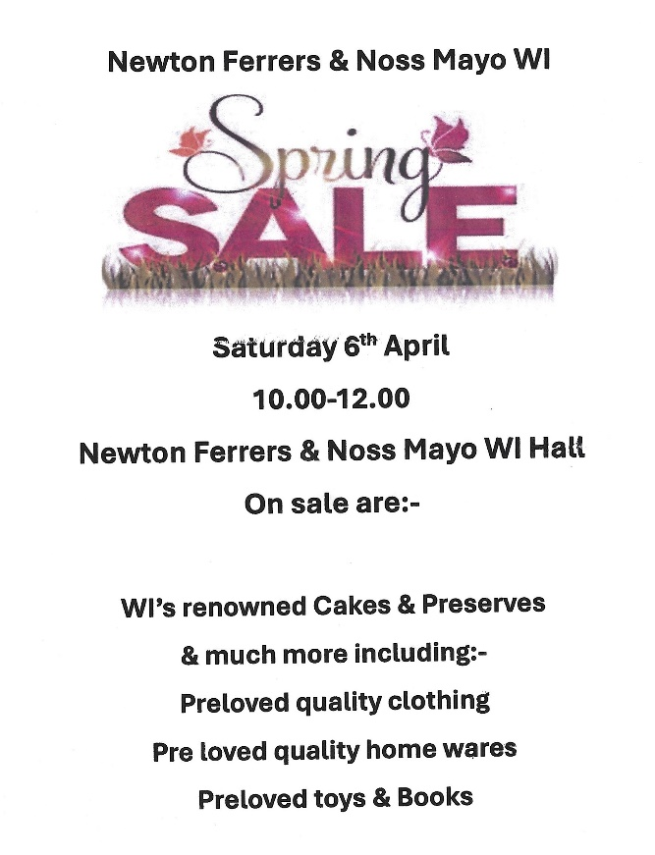
Tots and Toddlers Rockpool Safari Sunday 31 March 2024 3:00pm - 4:00pm Wembury Marine Centre, Wembury, Devon
Join us on an extremely low tide to explore Wembury’s most amazing rockpools, rarely uncovered by the tide

RYDA AGM 23/4/2024 Newton Ferrers Community Hall. 7pm.
Complimentary glass of wine or elderflower & guest speaker from Wembury Marine Centre

Revelstoke Community Trust annual meeting Wednesday 24th APRIL 2024 at which Grant Applications will be considered.

