RYDA Newsletter 04/2023

April Fools’ Day has been celebrated for several centuries by different cultures, though its exact origins remain a mystery. April Fools’ Day traditions include playing hoaxes or practical jokes on others, often yelling “April Fools!” at the end to clue in the subject of the April Fools’ Day prank. While its exact history is shrouded in mystery, the embrace of April Fools’ Day jokes by the media and major brands has ensured the unofficial holiday’s long life.
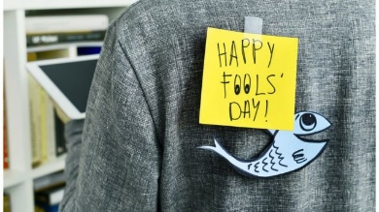
Origins of April Fools' Day
Some historians speculate that April Fools’ Day dates back to 1582, when France switched from the Julian calendar to the Gregorian calendar, as called for by the Council of Trent in 1563. In the Julian Calendar, as in the Hindu calendar, the new year began with the spring equinox around April 1.
People who were slow to get the news or failed to recognize that the start of the new year had moved to January 1 and continued to celebrate it during the last week of March through April 1 became the butt of jokes and hoaxes and were called “April fools.” These pranks included having paper fish placed on their backs and being referred to as “poisson d’avril” (April fish), said to symbolize a young, easily caught fish and a gullible person.

Hilaria in Ancient Rome
Historians have also linked April Fools’ Day to festivals such as Hilaria (Latin for joyful), which was celebrated in ancient Rome at the end of March by followers of the cult of Cybele. It involved people dressing up in disguises and mocking fellow citizens and even magistrates and was said to be inspired by the Egyptian legend of Isis, Osiris and Seth.

Vernal Equinox and April Fools'
There’s also speculation that April Fools’ Day was tied to the vernal equinox, or first day of spring in the Northern Hemisphere, when Mother Nature fooled people with changing, unpredictable weather.

History of April Fools’ Day
April Fools’ Day spread throughout Britain during the 18th century. In Scotland, the tradition became a two-day event, starting with “hunting the gowk,” in which people were sent on phony errands (gowk is a word for cuckoo bird, a symbol for fool) and followed by Tailie Day, which involved pranks played on people’s derrieres, such as pinning fake tails or “kick me” signs on them.

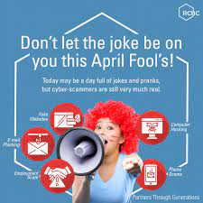
April Fools’ Day Pranks
In modern times, people have gone to great lengths to create elaborate April Fools’ Day hoaxes. Newspapers, radio and TV stations and websites have participated in the April 1 tradition of reporting outrageous fictional claims that have fooled their audiences.
Don’t be a Fool and fall for a scam this April. Spot and protect yourself from scams
It can be hard to tell if something is a scam - that’s why they work. Fraudsters are cunning and adapt quickly to convince you into parting with your money.
Ask yourself the following questions. If you answer yes to any of them, there's a good chance it's a scam.

- Have you been contacted out of the blue?
- Cold calls or unexpected emails or messages should raise suspicion, especially if you’re asked to give personal or payment details.
- It’s very unusual for legitimate organisations to contact you and ask for sensitive information if you’re not expecting them to.
- If you're not 100% convinced about the identity of the caller, hang up and contact the company directly.
- Have you been asked to share personal details?
- Never share your personal details with anyone if you can't confirm they are who they say they are.
- Phone scammers will often try and get valuable personal data from you, and they can use this to steal your money, or even to use your identity to use fraudulently.
- Are the contact details vague?
- Scam websites often Vague contact details can be a PO box, premium rate number (starting ‘09’) or a mobile number.
- If anything goes wrong it's important you can contact those involved. This will be difficult if you don't have accurate contact information.
- Premium rate numbers are also a favoured trick for squeezing every penny they can out of you.
- Are you being asked to keep it secret?
- It's important you can discuss any agreements with your friends, family or advisors.
- Asking you to keep quiet is a way to keep you away from the advice and support you need in making a decision
- Is the offer too good to be true?
- Scams will often promise high returns for very little financial commitment. They may even say that a deal is too good to miss.
- Use your common sense, if a deal is too good to be true, it inevitably is.
- Are you being pressured to make a decision?
- Fraudsters often try to hurry your decision making. Don’t let anyone make you feel under pressure - it’s OK to take a break and think things through if you’re not sure.
- Sales staff should always give you time and space to make an informed decision, anyone who tries to rush you should not be trusted.
- Are there spelling and grammar mistakes?
- Emails or messages littered with spelling and grammar mistakes are a scam giveaway. Legitimate organisations will rarely, if ever, make spelling or grammatical mistakes in their emails to you because they’ve been put together by professionals and checked before they’re sent.

Which reports the following current scams
Scammers are sending emails with Disney+ branding to lure victims with the promise of cut-price streaming subscriptions.
If you receive a scam email, you’d hope it would go straight into your spam folder – but unfortunately, that isn’t always the case. This latest dodgy email targets recipients with a '98% discount' on subscriptions to the Disney+ streaming service.
This scam email is sent from the address ‘DisneyPlus@costumercontact.com’. It claims to offer a Disney+ TV package for 12 months for the price of just £2 – a saving of 98%. A genuine Disney+ subscription costs £7.99 a month or £79.90 a year.
The email includes an image of the movie 'The Avengers' to make it appear more convincing.
The link included in the email encourages readers to click to activate a trial of the service.
When Which clicked on the link, they were taken to a website with the URL [c.zombiezalad.co.uk]. Each subsequent time they clicked they were taken to identical webpages with different URLs – [c.tenderfootninja.co.uk], and then [c.bumfuzzles.co.uk].
When you arrive on these websites, you’re asked to create an account by entering an email address and password. The site also prompts you to select your gender and home address.
The site features a countdown clock to tell you that the ‘offer’ will soon expire – this is designed to pile on the pressure and make you act quickly without thinking things through. If you enter your details, you’ll be giving them to the scammer.

Scammers are impersonating Amazon to get access to your device.
These scam calls involve fraudsters telling consumers that their Amazon Prime subscription is increasing in price or expiring. If you say you want to cancel, you’ll be asked to download remote access software such as AnyDesk. This is a genuine program that fraudsters sometimes use to exploit victims. Once you download the program, the scammer will be able to access your device and steal your information or install malware.

Beware of fake donation accounts for the Turkey-Syria earthquake
If you're considering donating to victims of the Turkey-Syria earthquake, keep in mind that scammers are always lurking to take advantage of such a crisis.
On social media, we've found pages, posts and videos containing misleading or false information about the earthquake. This is in an attempt to get people to send funds, including Bitcoin and NFT donations.
Learn how to make a safe donation to the Turkey-Syria earthquake.

Phoney HMRC tax refund emails
Fraudsters are impersonating HMRC and sending phoney tax refund emails. The emails include a link to ‘claim’ your refund. And if you click on the link, you’ll be taken to a website that puts you at risk of giving away your personal details to a scammer.
It is helpful to know that HMRC will never send specific tax information (such as how much you owe or any rebates due to you) by by email, so if you receive this email you can rest assured that it's a scam.
Check out these tips for identifying and reporting phoney emails.

What to do if you become a victim of fraud
Taking the following steps gives you a better chance of getting your money back, and warning other potential victims:
Report fraud to your bank or payment provider
If you’ve lost money to a scam and you paid with a credit or debit card, or sent money through an account transaction, tell your bank or payment provider as soon as possible. Most have a dedicated fraud hotline, the number for which you can find online.
For scams where money was taken from your account, you're legally entitled to your money back.
Where you sent money to a fraudster, you may be able to get your money back.
Report the scam to Action Fraud
Action Fraud is the fraud and cybercrime reporting centre for England, Wales and Northern Ireland.
You can report any attempt to steal your money or personal information to Action Fraud by calling 0300 123 2040 Monday to Friday 8am-8pm, or you can use their online reporting tool which is available 24/7.
Or https://www.ncsc.gov.uk/collection/phishing-scams

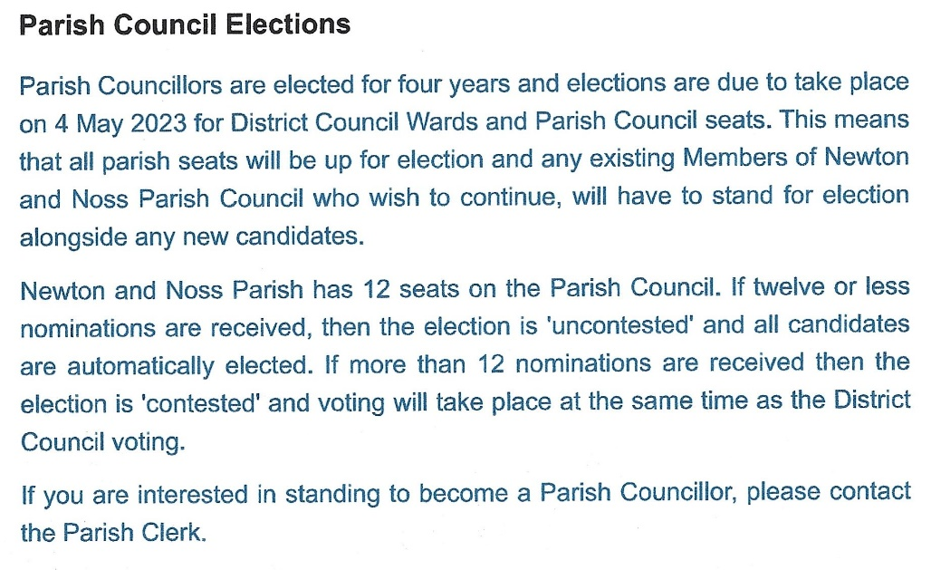

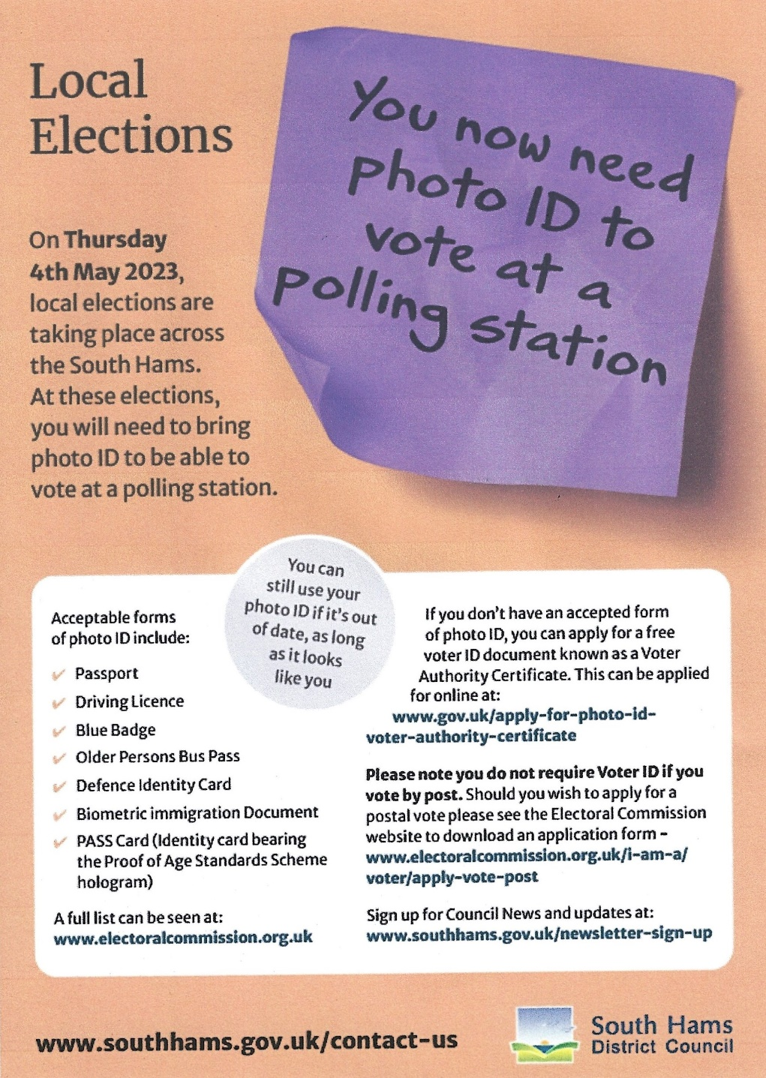

RYDA AGM Tuesday 25th April 7pm Noss Village Hall

While you may be familiar with International Paint Ltd’s (IPL) recent conviction and fine for polluting the Yealm Estuary, Devon, with banned TBT, the shocking twists and turns of the pathway to court reveals the continuing and pressing need to hold global multinationals to account. To read the report click here. (with thanks to Simon Friend)

“Harbour Clean Up 22April 2023.
Are you able to help?
We need a new team leader for the harbour clean up on the Spit at the harbour entrance due to the current leader leaving the village.
It is a fun and rewarding day a year.
Come and join the team.
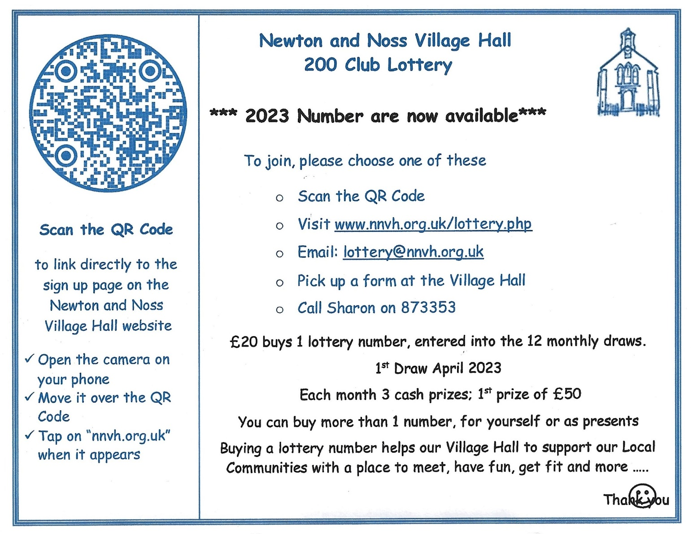
Please contact Andrew Beveridge, email beveridgeandy@gmail.com if you can spare the time”
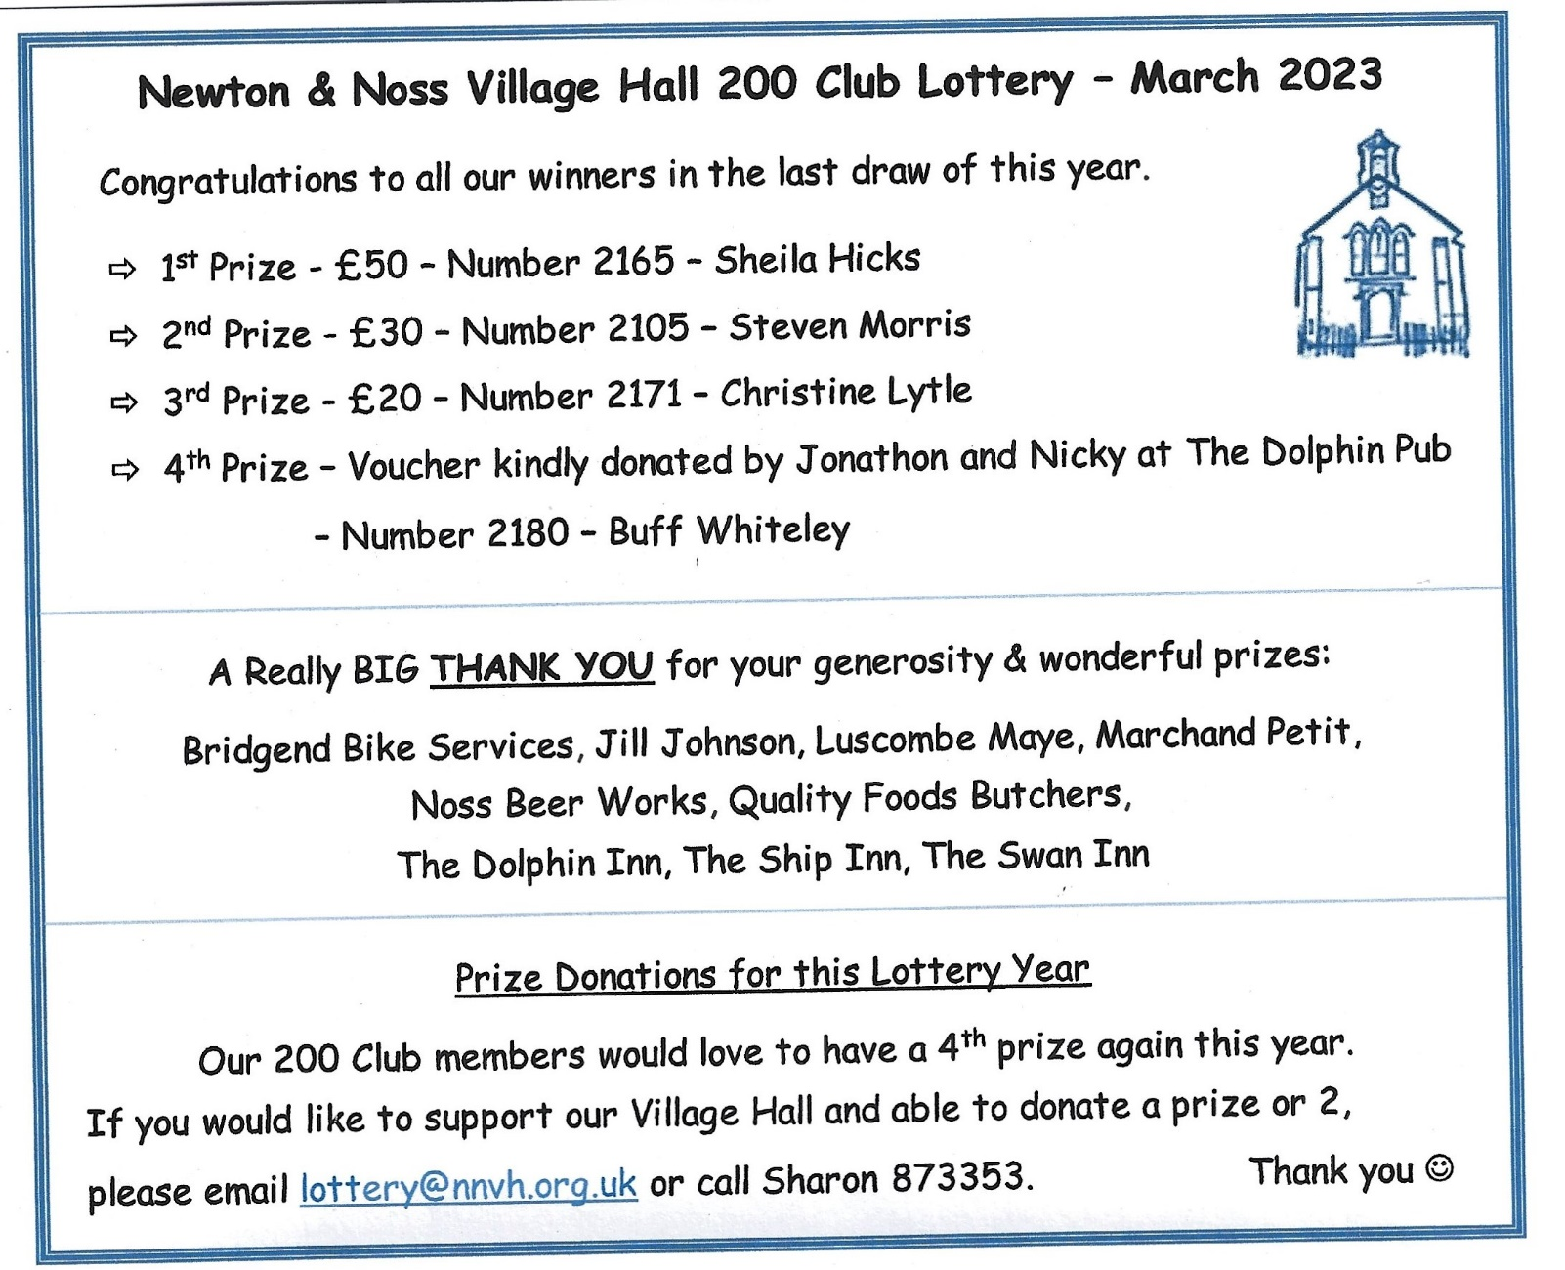

PLANNING
Yealm Gig Rowing Club Development Plan

0196/23/HHO
(Resubmission of 1147/22/HHO)
Address: Langdale Noss Mayo. Planning Application Ref. 0196/23/HHO (Resubmission of 1147/22/HHO)
This is the only item of significant interest this month. A proposed update to a bungalow, Langdale on Foundry Road in Noss, to make it slightly larger and a more family useful size. It is intended to achieve this by building a first-floor extension, but to not increase the roof height above the neighbouring building, the extension will have a flat sedum roof with solar panels. This gives a somewhat modern appearance which may be at odds with the location immediately adjacent to the Conservation Area. The view below is from Foundry Road. We would be pleased to have your thoughts on this application.

WHATS ON

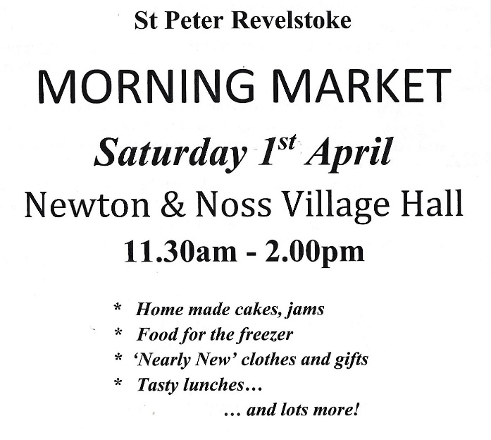

Tuesday Lunch Club 4th April at 12.00 £6 2 courses plus tea/coffee. New members always welcome.
Contact Jeanne (872442) or Jane (872627) Allergies can be catered for.
The menu varies. – In March we were treated to a Roast lunch followed by Lemon Merengue Pie.

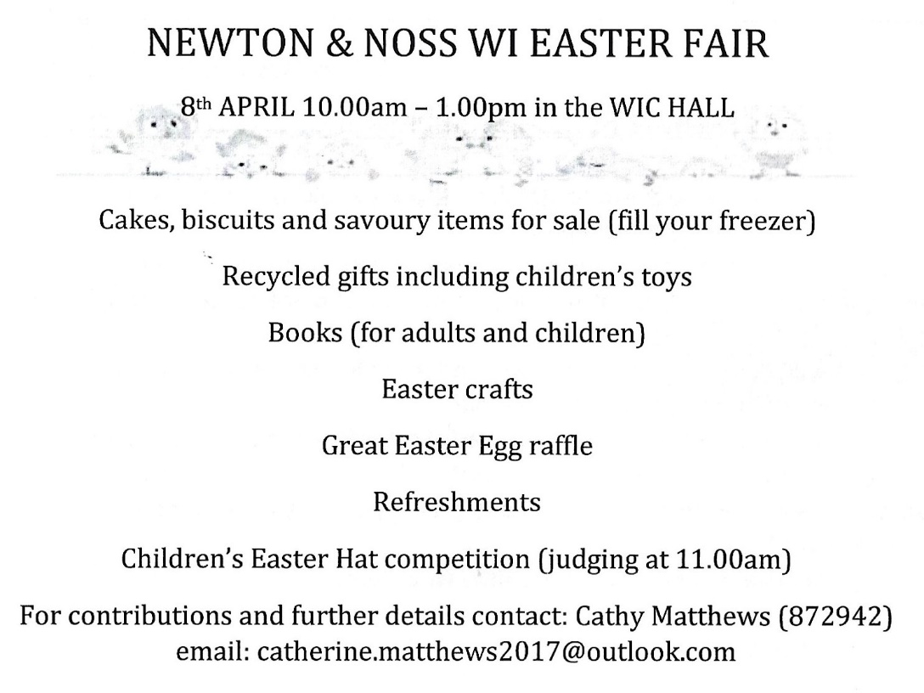

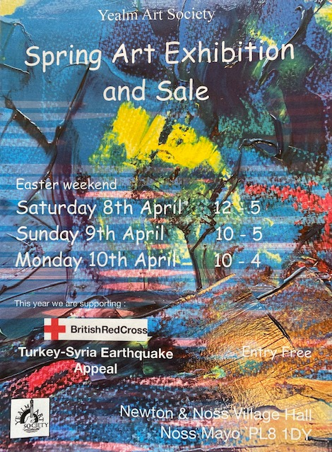

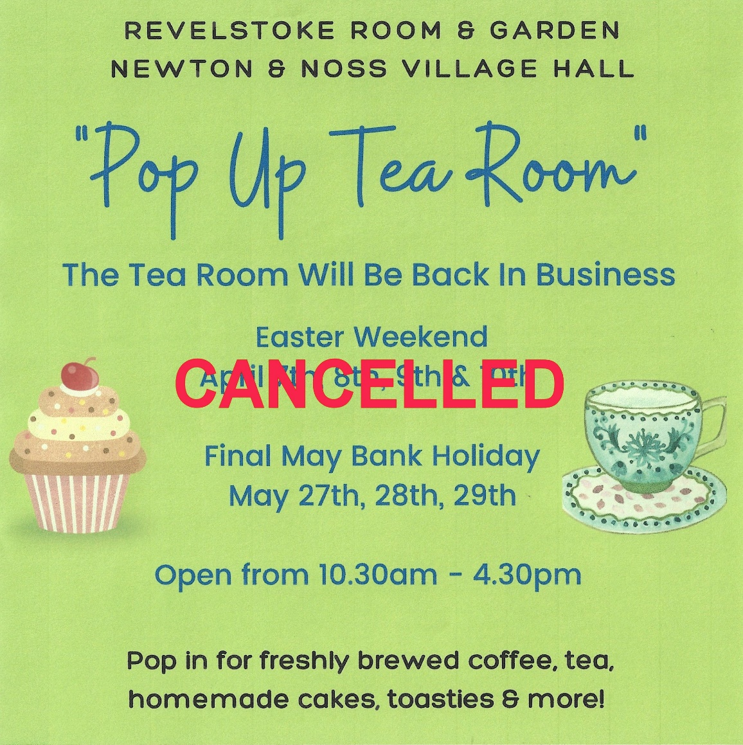

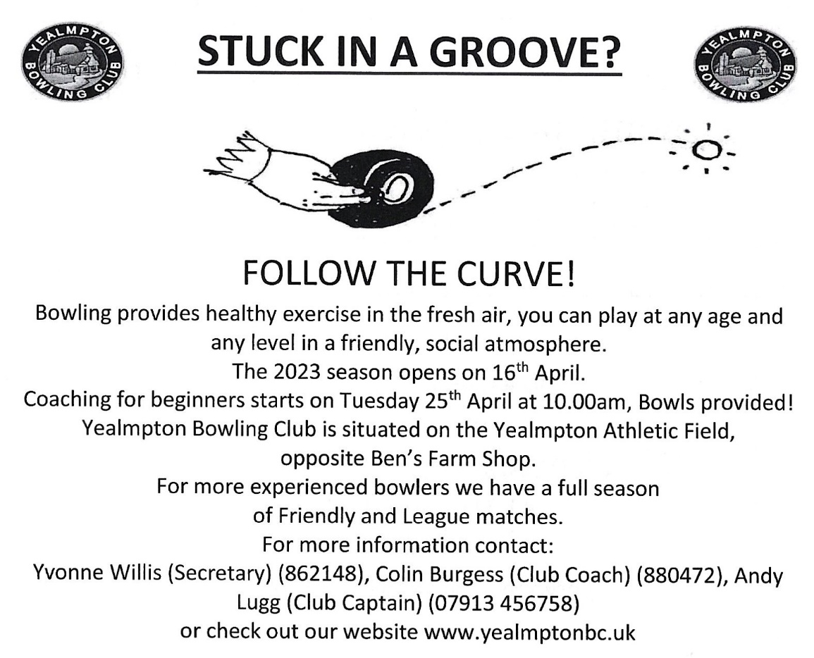
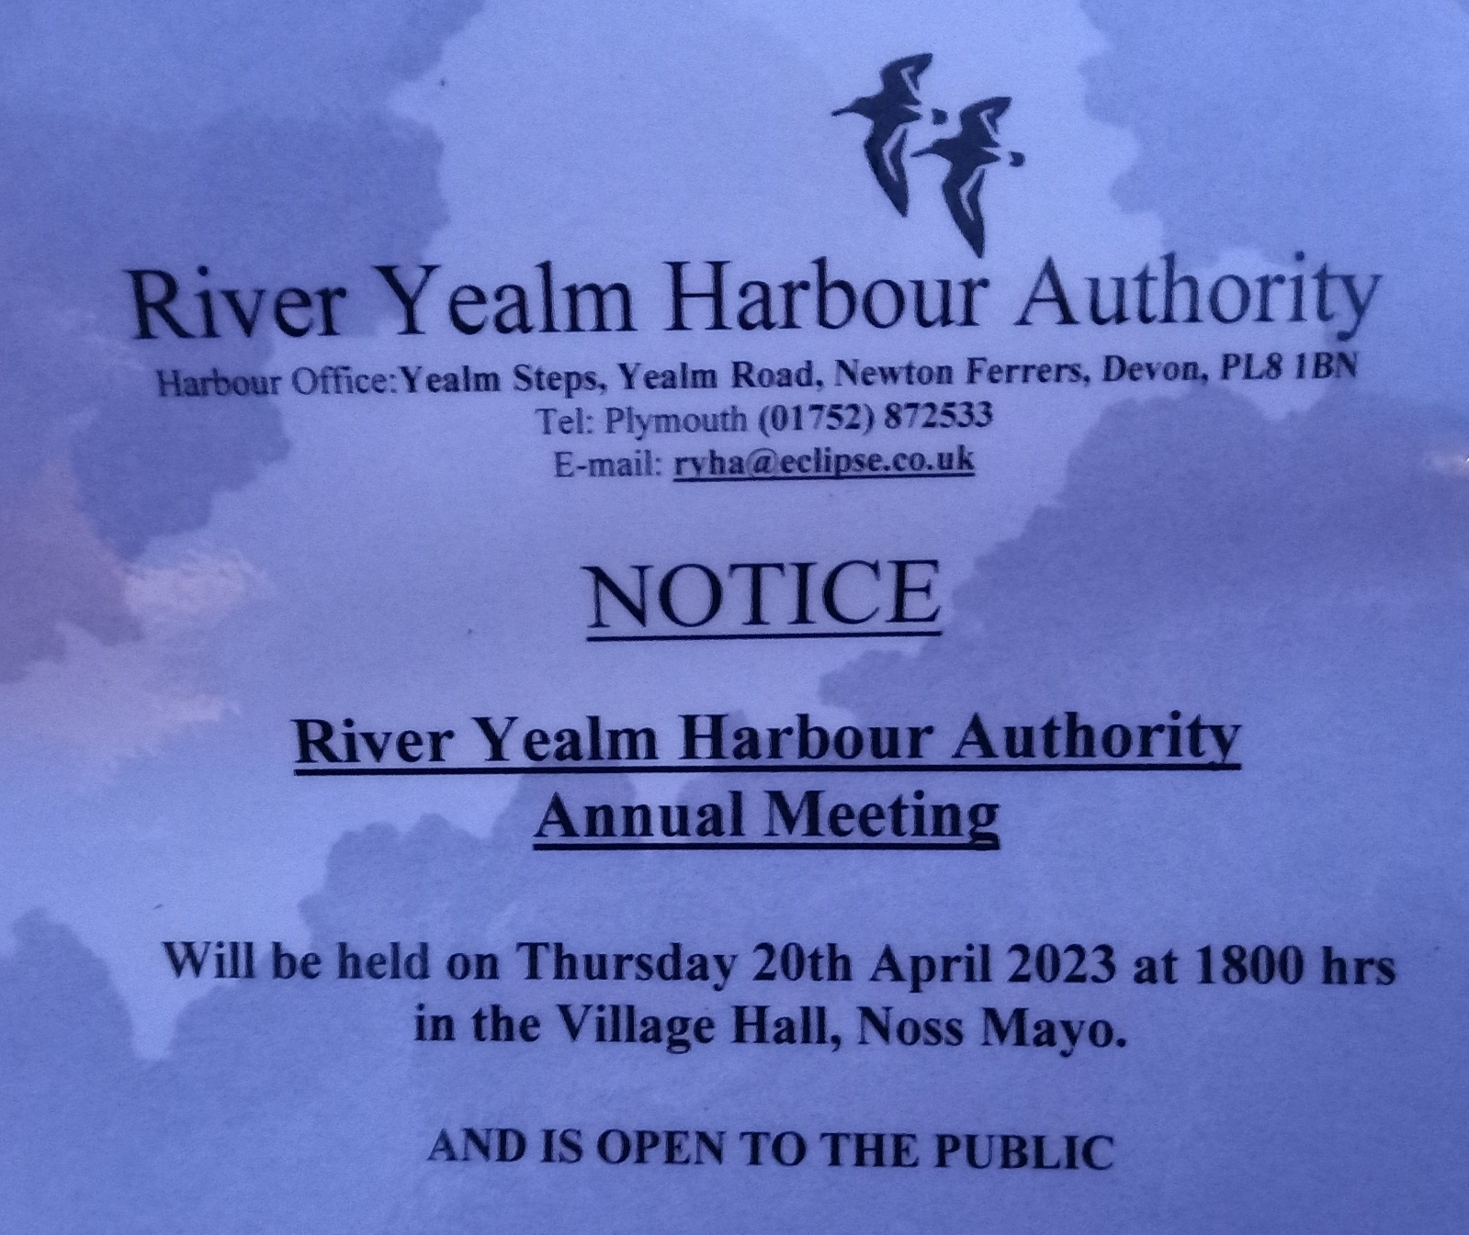

Harbour Clean Up is Sat 22 April

Thursday Lunch Club Noss Mayo Village Hall 27th April 12.15 2 courses plus tea/coffee. £6 New members always welcome. Contact Jane (872663) mrandmrsbarnett@gmail.com Allergies & Vegetarians can be catered for.
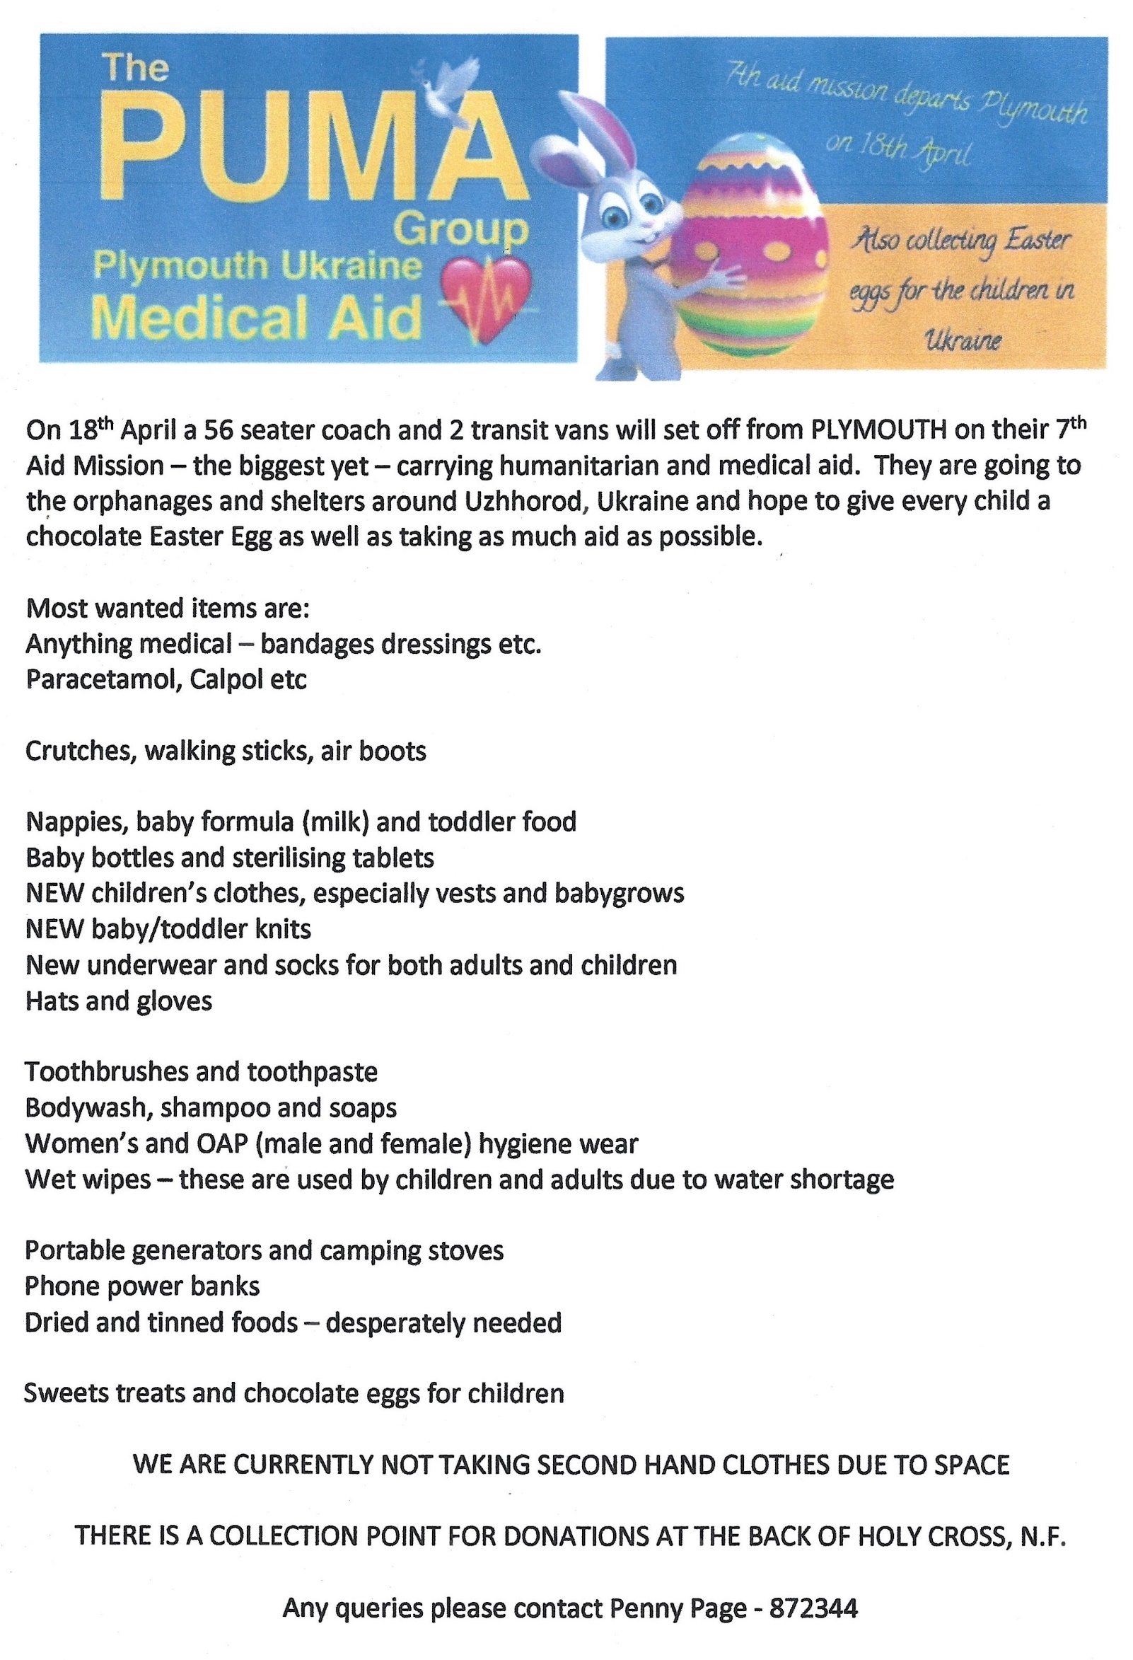
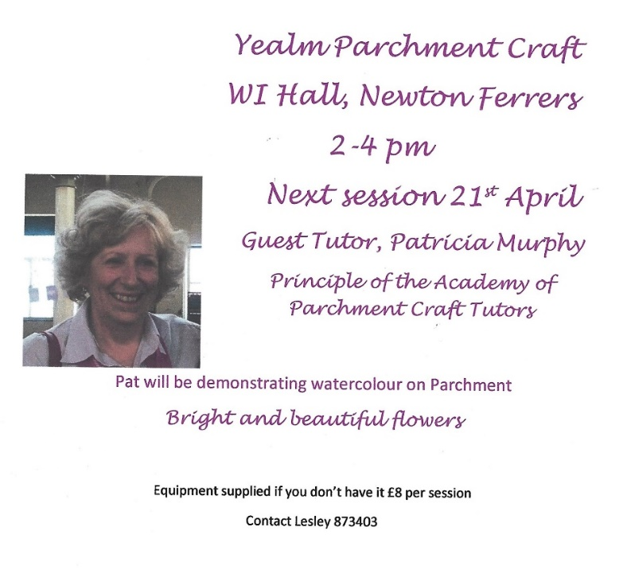

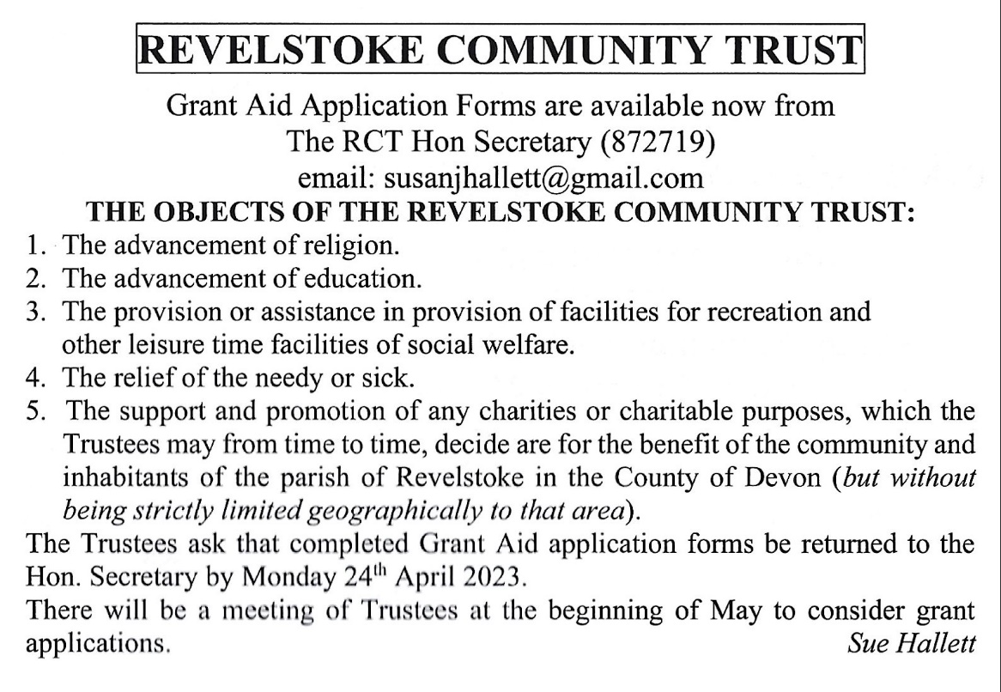

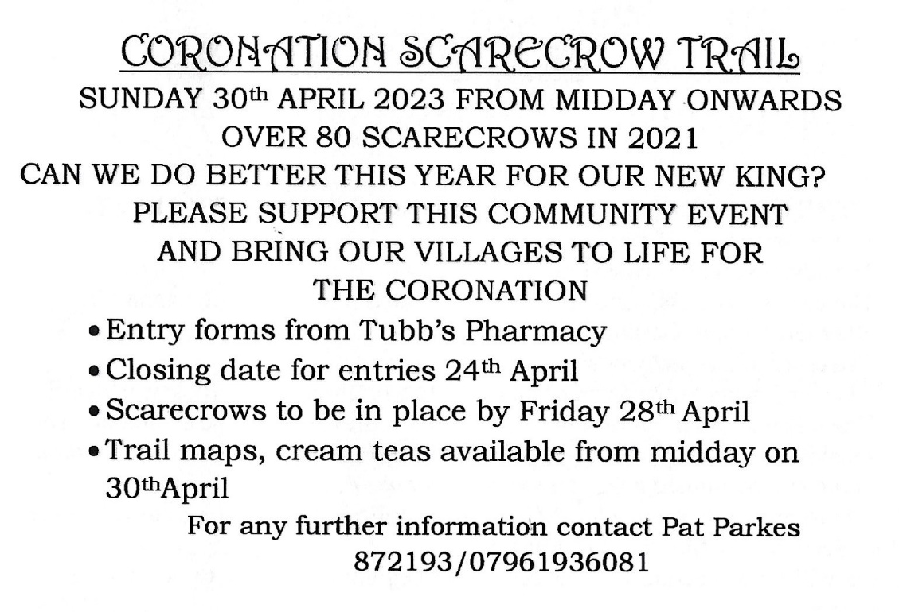

WI Craft Group
Project: Magic Quilted Style Baskets
25th April 2pm – 4pm
Things to Bring with you
12 buttons or a length of ribbon or bias binding
Scissors suitable to cut fabric
Thread and needle (for sewing on buttons or ribbon)
12 pegs or pins (to hold things in place)
Important Things
Tea & coffee being made by
Cost Total £2
Hall £1
Refreshments £0.50
Materials £0.50 (iron on interfacing)

