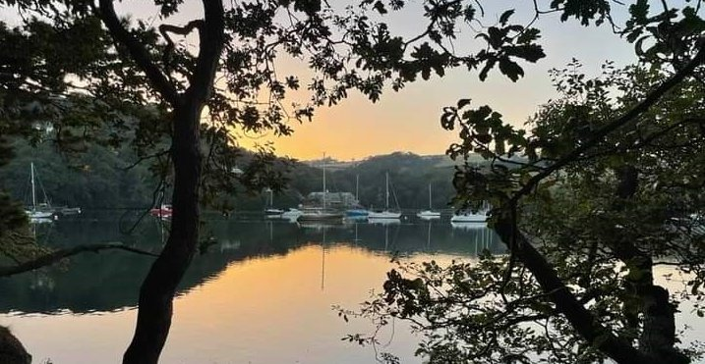
RYDA Newsletter 2024
Even though British English is often considered the “standard” form of the language, it has its own brand of funny British phrases and unique British idioms. While some of these British colloquial phrases evolved over the centuries, others were added to the common vernacular quite recently.
Rule of Thumb; before thermometers were invented, brewers would dip a thumb or finger into their alcoholic concoction to find the right temperature for adding yeast.
Too cold, and the yeast wouldn't grow. Too hot, and the yeast would die.
Nowadays, the expression ‘rule of thumb’ means a broadly accurate guide or principle.
Another possible derivation for this phrase comes from an ancient custom whereby men were permitted to beat their wives – but only with a stick no thicker than their thumb. This is also where the phrase ‘to have someone under your thumb' comes from.
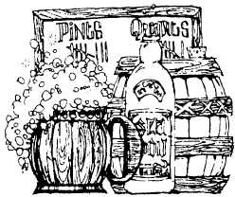
Mind your P’s & Q’s; In old England, ale used to be drunk in pints and quarts.
When customers got unruly, the innkeeper would yell at them to ‘mind their pints and quarts’ – in other words, to ‘settle down’.

Wet your whistle’ Many years ago, pub customers had a whistle baked into the rim or handle of their ceramic mugs. When they needed a refill, they used the whistle to get some service.
‘Wet your whistle’ is a phrase inspired by this practice. These days, the phrase has simply come to mean ‘to have a drink’.
Honey Moon; It was the accepted practice in Anglo-Saxon England years ago that for a month after the wedding, the bride's father would supply his son-in-law with all the mead he could drink (it was supposed to make the wife fertile and the husband virile).
Mead is a honey wine – and because the Anglo-Saxons used a lunar calendar, this period was called the ‘honey month’, or what we know today as the ‘honeymoon’.
To bring someone down a peg or two; In olden times people would share a drinking vessel called a 'pigin', which was passed around the drinking circle. When it was your turn to drink, you drank down to your mark, or ‘peg’. If you upset the crowd you had to miss a few turns, hence you were brought down a 'peg or two'. Nowadays, the phrase means to reprimand someone acting arrogantly.
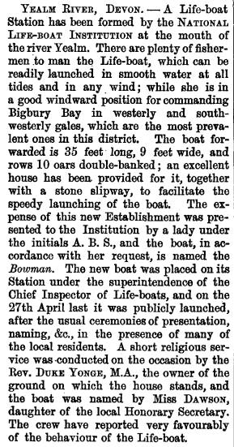
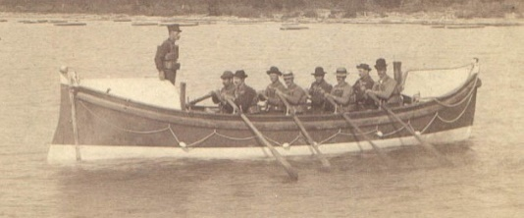

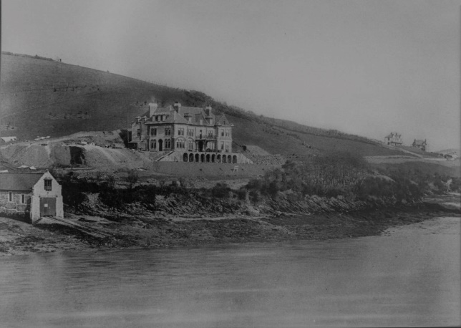
The Royal National Lifeboat Institution established a lifeboat station at the mouth of the Newton Creek in March 1878. A stone boat house was built, and the boat was launched into the River Yealm using a slipway. The station was closed in 1927 by which time Plymouth Lifeboat Station had been equipped with a motor lifeboat which could cover the area more effectively. During its 49 years three different lifeboats operated from the ‘Yealm River Lifeboat Station’:- Bowman (1878), (1887) and Michael Smart (1904).

Yealm Dippers
Volunteers studying long term river health on the River Yealm are known as “Yealm Dippers”. Yealm Dippers contribute to:
• water quality measures designed to monitor background water quality on an approximate monthly basis, as part of the Westcountry Rivers Trust’s (WRT)
- management of an automated instrument, the “Yealm Sonde”, which monitors water quality continuously, alerting to transient events whilst defining our rivers chemistry and physics; and
- measures of aquatic insect diversity as indicators of ecological health, in partnership with Wildfish’s Smartrivers

To read the report follow this link
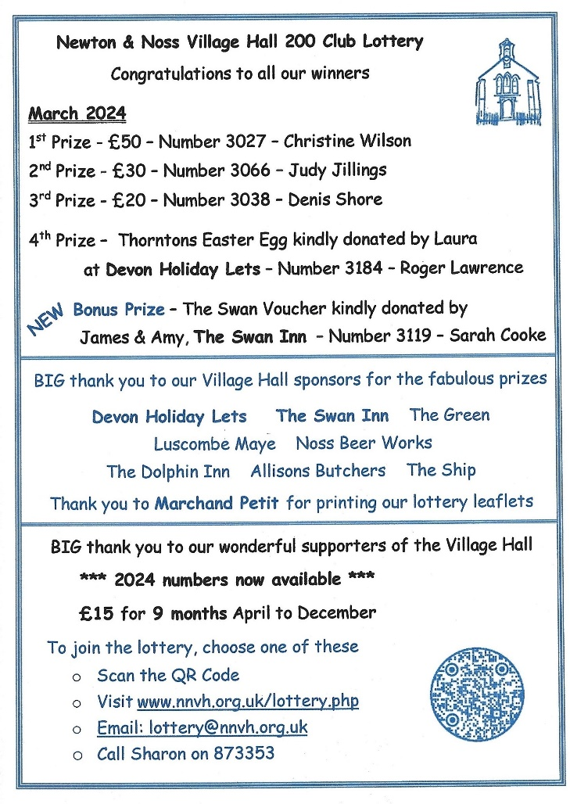

The ladies of the WI were asked if they could provide some Easter Eggs for Ivybridge food bank for the benefit of children whose parents might not be able to buy an egg.
​
They answered the call and we were able to donate 43 Easter Eggs. Well done Ladies

Telephone companies are preparing to switch to digital landlines by 2025, which may mean your landline or broadline changes. You can find out a bit more about the digital switch and what this may mean for you below.

What is the digital switch?
Between now and 2025 most telephone and broadband providers will be moving their customers from old analogue landlines over to new upgraded landline services using digital technology.
Providers are performing these upgrades to improve the quality of service their customers get.

What could happen?
You may be approached by your current provider or a new provider to install a new line.
There are two types of line available, open or closed. If you get an open line, this means any provider (ie BT; Gigaclear; EE etc) can use the line. This means if you move house, you will not need a new line installation to stay with your provider. A “closed” line with e.g. BT; will mean you have to stay with BT; - no other provider can use that line to provide services.
If you live in a block or flat, or your property has internal communal areas, your landlord may only allow a limited number of closed providers to install in the property depending on the height of the building this decision is to reduce the fire risk caused by additional electrical wiring.

How to check if you have an analogue line
If you are not sure if you have an analogue line that will be replaced as part of the switchover, you can check by:
Checking your bills.
Asking your provider.
If you have a fully functional phone where the wire goes directly into the wall without a separate box inside or outside the home, your line is likely to be analogue.

What do you need to do if you have an analogue line?
If you have your own telephone line, internet, CCTV or lifeline alarm that you pay another provider and suspect that it is an analogue line, or if you are not sure, please speak to your provider. They can advise what options are available if you wish to continue using the line.

Planning
0374/24/HHO 75 Road from Swan Inn to Head of Noss Creek.
Householder application for proposed re-alignment of roof pitch to match adjacent property, proposed loft conversion, proposed new roof & balcony to existing rear tenement block.

0375/24/FUL Development Site at Sx 5411 4806 Lower Court Road, Newton Ferrers. New detached dwelling, associated access improvements, car parking & landscaping.

0660/24/FUL 1 The Point Passage Road Noss Mayo. Introduction of holiday let use to existing annexe.

0921/24/ARC Tides Reach 8 Yealm View Road Application for approval of details reserved by condition 3 (Materials) of Planning Consent 3672/23/HHO.

0689/24/VAR Newton Downs Farm Application for variation of condition 2 (approved plans) of planning consent 4462/22/FUL to include a single storey extension with the barn conversion.

4142/23/HHO Newton Farmhouse, Barn Cottage, Parsonage Road,
Householder application for partial demolition and reconstruction of first floor accommodation/detached garage and associated works

Steps Cottage, Lower Court Road. G1: Oak - removal of dead or snapped branches (deadwood exempt) from property boundary, o remove risk of property damage & T1: Oak - Reduction of 1x over-extended limb on south side by 2m to reduce chance of failure and damage to property Under Consideration

Application number 0374/24/HHO Creekside Road
One of a group of cottages; No. 75, on the road from the Swan Inn to the head of Noss Creek (known as Creekside Road), near the junction of Creekside Road with Hillhead, this application, for the raising of the roof ridge is said to match adjacent properties, although it appears from the drawing to be slightly higher than its neighbours. To include a loft conversion, with a new roof and a balcony to the existing rear tenement. The proposed flat roof extension to the rear, close to Listed Buildings, may be incongruous in the heart of the Noss Conservation area, as it will be visible from Hillhead and properties on Revelstoke Road.
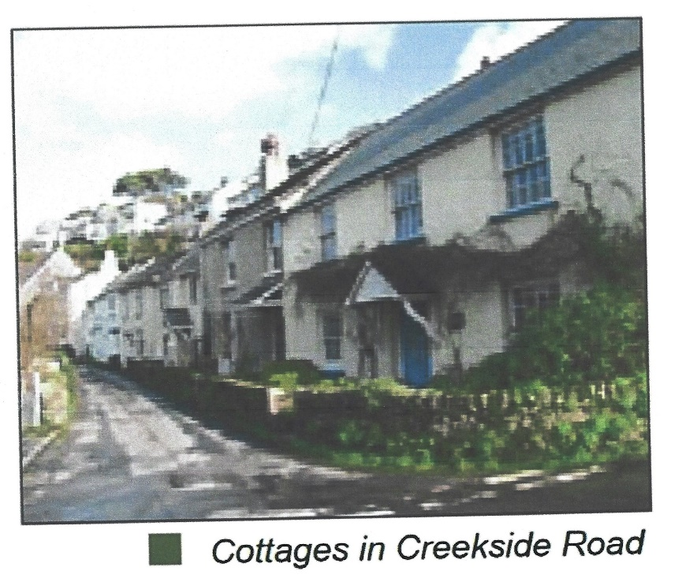

0375/24/FUL. New dwelling, Lower Court Road.
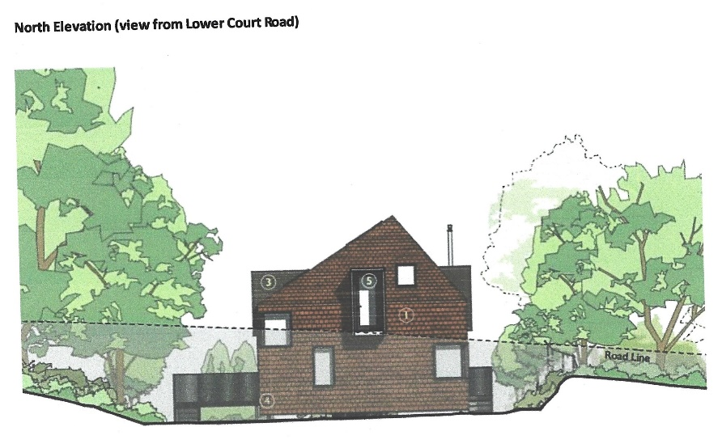
The proposal at a “development site” on Lower Court Road, for a new detached dwelling, with associated access improvements, car parking & landscaping. The proposal is a relatively modest new dwelling of muted design. The location is close to, but below the road level and close to the top entrance of the public footpath which runs from Lower Court Road down to the bus turning bay on Yealm Road. This will be clearly apparent from the road, the path and, at distance, from the area of the SW coastal footpaths. The new dwelling will sit within the lightly wooded area in what was part of the land surrounding the old Yealm Hotel. This land was designated as part of the landscaping Woodland Management Plan, approved by condition, on the development known as “The Yealm”.

This Plan originally proposed to clear invasive species and plant with a mixture of native trees, e.g. hazel and spindle.
Occupying part of the promontory between the main River Yealm and the Newton Arm, will this new house detract from the beauty of the National Landscape?
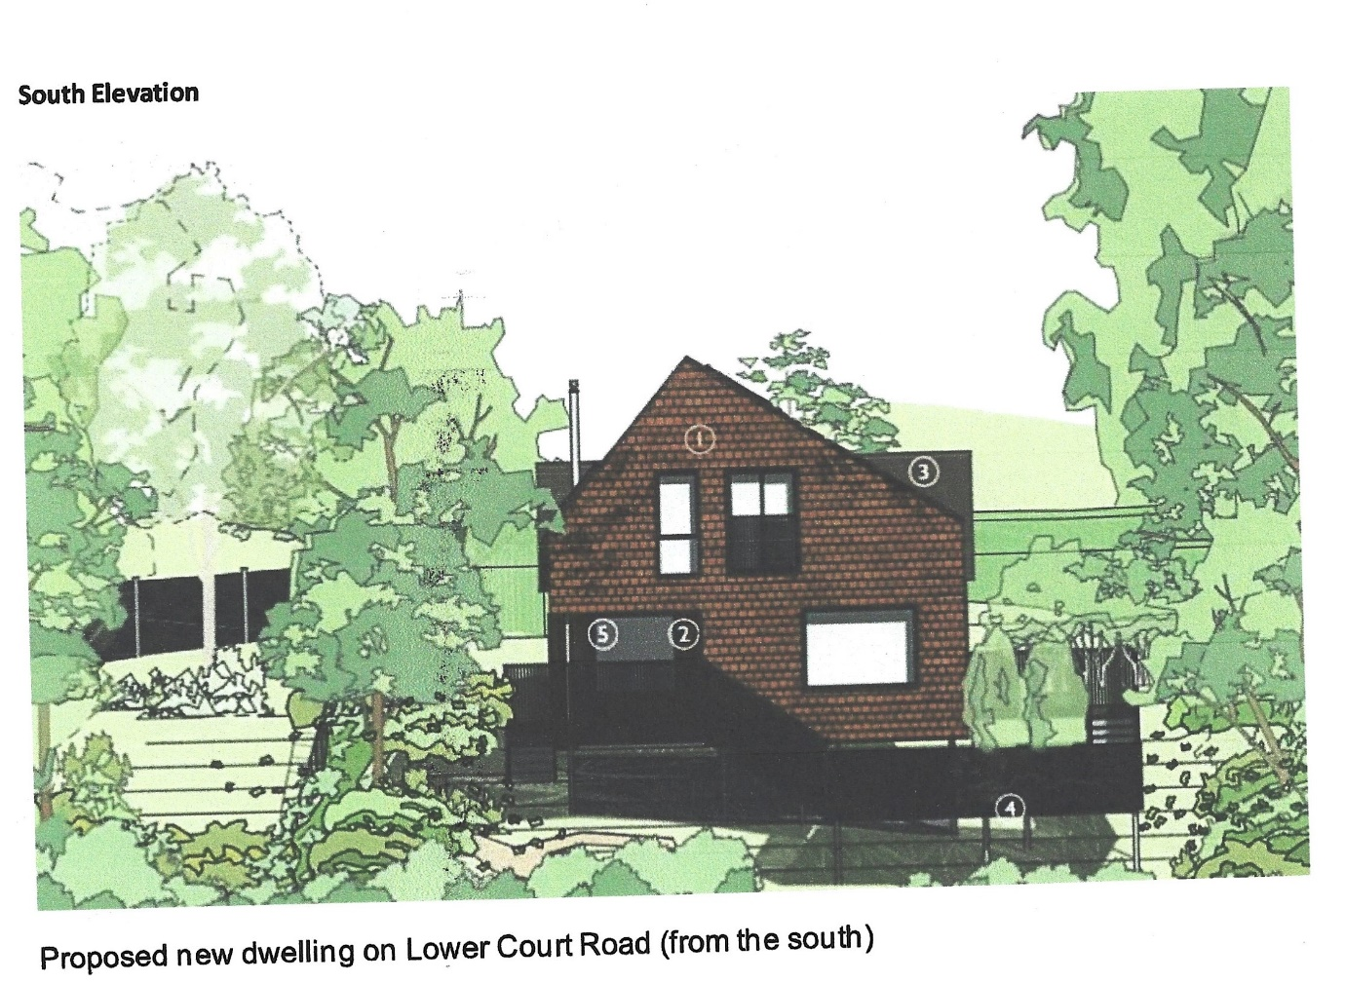

0660/24/FUL. The Point, Passage Road. This is an application for the introduction of holiday letting use, to the existing small annexe situated on the riverbank at The Point on Passage Road, Noss Mayo. The annexe was previously used, with planning approval, as a very pleasant café. Although there are no changes to the building, given the narrow road access and restricted parking on Passage Road, does Noss need another short-term holiday let?

Appeals
Two Appeals against Refusal have also been received. They would each have significant negative impacts on the natural appearance of the waterfront areas of the river.

3953/21/FUL. 101, Yealm Road Demolition of 2 two-storey detached buildings & associated garage. Erection of 2 x.four bed family homes. Extension of an existing quay to the east of the site to provide a new landing ramp for dwelling 2.
You may remember that this application was for two large new dwellings on the site of the old paint laboratory. Generally they were deemed to be too large, dominating and out of keeping with the character of the location, resulting in an incongruous addition which fails to conserve and enhance the landscape and scenic beauty of this part of the South Devon Area of Outstanding Natural Beauty.

2928/22/FUL. Venta, 71, Yealm Road.
Proposed boatshed and reinstatement of Landing (Retrospective).
Although a less substantial development than above, nonetheless this application, if approved, would have an adverse impact on this undeveloped and unspoilt section of waterfront to the detriment of its character, appearance and tranquillity.

Please let us know your thoughts on these and any Planning Applications, we also encourage you to inform the Parish Council.

What’s On
1st April Yealm Art Society Exhibition & Sale N&N village hall 10.00-16.00

2nd April 12.00 noon 1st Tuesday Lunch Club £6pp. for 2 course meal plus tea or coffee. Newton Ferrers Community Hall. Allergies can be catered for. Please contact either Jeanne (872442) or Jane (872627) New members welcome

3rd April & 10th April NO Exercise class Sit back and relax for Easter
Class resumes April 17th at 10.00 £5 pp. Seated exercise class. Run by physiotherapists. New members welcome

12th April Holbeton Film Club are showing The Unlikely Pilgrimage of Harold Fry @ 7.00 for 7.30. Harold is an ordinary man who has passed through life, living on the side lines, This seemingly unremarkable man in his sixties one day learns that his old friend Queenie is dying. He goes to mail a letter, only to keep walking for over 700km until he reaches Queenie's hospice, much to the despair of his wife Maureen.

15th April 10.30am Stoke support Group in the WI Community Hall meeting room.
16th April 7.00pm WI (note change of time) the speaker is Hugh Gerard – “How I accidentally became an author”.

18th April RYHA AGM N&N village hall
21 April 9.30-4.30 Neighbourhood Plan Review WIC Hall
23rd April 7.00pm RYDA AGM WIC Hall Complimentary glass of wine or elderflower & guest speaker from Wembury Marine Centre

24th April RCT Annual Meeting Bridgend House Noss Mayo

25th April Thursday Lunch Club 12.15 £6.00 Newton and Noss Village Hall. The tide will be low at 13.41. Please contact mrandmrsbarnett@gmail.com Allergies can be catered for, also vegetarian option available. New members welcome
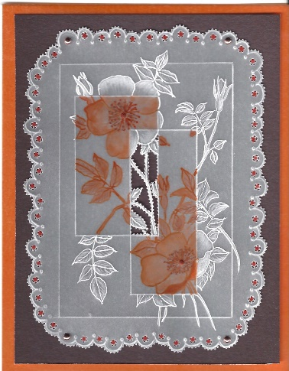
26th April 14.00 – 16.00 Yealm Parchment Group
This month we will be trying to do fine snipped lines, with a bit of ink painting. £8 pp. Includes pattern, parchment. Backing card, Brads and tuition. Tools are available for those wishing to try this fascinating hobby for the first time. Tel Lesley 873403 Own table to ensure social distancing.

Wednesday 24th APRIL 2024 Revelstoke Community Trust annual meeting at which Grant Applications will be considered.
27th April. National Theatre at Newton & Noss WI Community Hall 7.00pm (doors open 6.15) Tickets £12 from Post Office - Cash bar available, NO interval
Andrew Scott brings to life multiple characters in Simon Stephen’s radical new version of Anton Chekhov’s Uncle Vanya.
Comedic and tragic, Chekhov’s examination of our shared humanity - our hopes, dreams, regrets - is thrust into sharp focus in VANYA.
This production explores the kaleidoscope of human emotions, harnessing the power of the intimate bond between actor and audience to delve deeper into the human psyche.
Newton Ferrers WI Community Hall

30th April Holy Cross Coffee Morning
30th April Yealm Garden Society talk in WIC hall @ 7.30 by Mark Walsh ~Tamar Valley Crocosmia & other South African Beauties

Regular Weekly Events around the Parishes of the River Yealm
Please check with venue/organiser
Events may be cancelled around school holidays.
Day | Time | Details | Venue/ contact number
Mon | 12.45-15.45 | Upholstery group | WI Hall Newton Ferrers
 | 9.00 -12.00 | Men’s Shed | Men’s Shed Yealmpton
 | 16.00-18.15 | Ballet | WI Hall Newton Ferrers
 | 18.00-19.30 | Tai Chi | Newton & Noss Village Hall
 | 19.00-21.00 | Badminton | Yealmpton Gt Hall
Tues | 10.00-11.00 | Gentle Exercise | Yealmpton Methodist Church
 | 10.00-11.00 | Yoga | Yealmpton 0780971765
 | 10.00-12.00 | Bowling | Yealmpton Bowling Club
 | 10.30-11.30 | U3A Table Tennis | Newton & Noss Village Hall
 | 12.00 13.00 | Pickleball | Newton & Noss Village Hall
 | 18.15-19.15 | Yoga | Yealmpton 07985532992
 | 19.30-20.30 | Vinyasa Yoga | Yealmpton 07985532992
 | 19.30-21.30 | Bridge | Yealmpton 880613
Wed | 9 am-12.00 | Men’s Shed | Men’s Shed Yealmpton
 | 10.00-11.00 | Gentle exercise | WI Hall Newton Ferrers
 | 10.00-13.00 | Wembury Community Hub (tea, games etc) | Knighton Room,  Wembury Village Hall
 | 10.30 | Gentle Walking group | Car Park Barton Close Wembury
 | 12.15 | Pilates | Newton & Noss Village Hall
 | 14.00 | WI Choir | WI Hall Newton Ferrers
 | 17.45-19.30 | Karate | Yealmpton 0787360391
 | 18.00 | Bridge | WI Hall Newton Ferrers
 | 18.00 | Gig Exercise Class | Newton & Noss Village Hall
Thurs | 9.30 | Sarah’s fitness (alt weeks) | WI Hall Newton Ferrers
 | 9.30 – 11.00 | Stay & Play  Play group | Holbeton Village hall toobattycross906@btinternet.com
 | 10.00-12.00 | Artistik story time | Holy Cross Church
 | 10.30-11.30 | Reading Group | Yealmpton Parish Rooms
 | 12.45 | Yin to Yang Yoga | WI Hall Newton Ferrers
 | 19.00-21.00 | U3A Table Tennis | Newton & Noss Village Hall
 | 19.00 | Pilates | Rose & Crown function room
Fri | 10.15-12.00 | Digital Drop-In | WI Hall Newton Ferrers
 | 10.30 | Yealmpton & Brixton coffee | Yealmpton Community room
 | 10.30 | Songs & Stories | Yealmpton Methodist Church
 |  | Poetry Group | Yealmpton 07749206347
Sat | 10.30-12.30 | Accessible Bowls | WI Hall Newton Ferrers
 | 9 am-12.00 | Men’s Shed | Men’s Shed Yealmpton

Save the Date
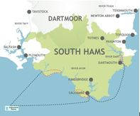
3 Creeks Race
May 16-17, 2020
South Hams, Devon
The Three Creeks Race is for teams of sailors and trail runners looking for adventure in a unique race that combines endurance, nautical skill and the beauty of the South Hams coastline in a weekend.
Dartmouth - Salcombe - The Yealm
We’re breaking with tradition and having the briefing (and importantly breakfast ) at the Royal Dart YC in Kingswear this year.
We’re also planning a slight change to the 1st run, a new rowing-based start on Sunday and a visit to the Victoria Inn Saturday evening for FREE BEER no less. Enter here
The Course
Starting in Dartmouth, pairs of runners from each team undertake three trail runs primarily along the coastal footpath and two sailing legs taking in Salcombe and the Eddystone Lighthouse before finishing in the Yealm.

80th Anniversary of D-Day Beacon Lighting Event
The Parish Council and the Yealm Branch of the Royal British Legion are delighted to be organising a beacon lighting event, near the coast path at Carswell Farm, to commemorate the 80th Anniversary of D-Day on the evening of Thursday 6th June. The Parish Council and Yealm Branch of the Royal British Legion are busy planning this community event and further details will be available in the coming weeks.
In the meantime, please put this date in your diary as we would like to see you all there.
You can read more about this national event here: www.d-day80beacons.co.uk.

